Dr. Ake Almgren
Chair, PJM Board of Managers
PJM Interconnection, LLC
2750 Monroe Boulevard
Audubon, Pennsylvania 19403

March 20, 2019
Re: April 3, 2019 Liaison Committee Meeting Final Agenda
Dear Dr. Almgren:
The members of the Liaison Committee (“LC”) and I appreciate the Board of Managers’ (“Board”) offering support for the proposed Fuel Security and Report on the GreenHat Default agenda topics. The LC members also support the Board’s view that transmission issues, including matters related to supplemental projects, are ripe for consideration. The LC members believe that dedicating ample time to each of these important topics provides an opportunity for fulsome discussion with the Board that may be inhibited by time constraints. To that end, the LC members propose a holistic discussion on transmission issues at the July 30, 2019 LC meeting that would include the subject of supplemental transmission projects.
The PJM stakeholders have been patiently waiting for the independent investigation report on the GreenHat FTR Default since the end of 2018. As the April 3rd LC meeting is just a couple of weeks away, stakeholders are discouraged and frustrated that the report, as of today, has not yet been made available. Thorough review prior to our meeting is necessary for a productive discussion with the PJM Board about the contents of the report. Making it available to stakeholders as soon as possible in a non-redacted format is critical to achieve this goal.
The agenda for the meeting is below and we look forward to our discussions on these topics with you and the PJM Board.

* * *
AGENDA
- Opening Remarks (10 minutes)

- Fuel Security (50 minutes)

PJM staff published its initial analysis on fuel security in December 2018. The analysis is a deterministic, scenario-based view of the potential consequences of, in PJM’s view, “a series of extreme, but plausible events”. PJM has developed a problem statement and issue charge to commence stakeholder deliberation on what it means to be fuel secure, to determine whether there needs to be a requirement for fuel secure resources in PJM, and potentially determine the mechanism to value fuel security in PJM. Solutions may be offered in either the capacity or energy markets. Stakeholders are scheduled to vote on this work effort at the March MRC meeting. Despite the lack of a comprehensive risk analysis centered on a probabilistic analysis, PJM appears, based on external communications, to have concluded that a solution is necessary despite the practicality of the solution, the market ramifications, the cost to consumers, or the benefits to consumers. The Members would like to discuss the status of this project with the Board, and share thoughts on the process and analysis that has been provided to date.

- Independent Investigation Report on GreenHat FTR Default (55 minutes)
Members would like to discuss the investigation of the events surrounding and PJM’s actions related to the GreenHat default in the FTR market. Members wish to discuss the specific findings of and the recommendations made by the independent investigative team. In addition, Members would like to provide their perspectives on the next steps for action items as well as hear the Board’s perspective on the next steps following the report.
- Closing Remarks (5 minutes)
* * *
The LC members and I greatly appreciate the Board’s consideration of these important issues and look forward to an engaging discussion during our April 3, 2019 meeting at the PJM Conference and Training Center in Audubon, PA.

Very truly yours,
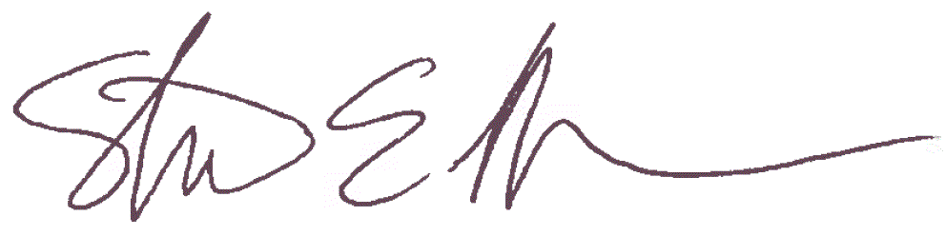
Steven Lieberman
American Municipal Power
Liaison Committee Chair

CC: Mr. Andy Ott, PJM Interconnection, LLC
Mr. Dave Anders, PJM Interconnection, LLC

PJM’s December 17, 2018 Fuel Security Analysis at 2.

