Special Session of the Market Implementation Committee: Variable Operations and Maintenance Costs
PJM Conference & Training Center, Audubon, PA
November 15, 2017
2:30 p.m. – 4:00 p.m. EPT

Administration (2:30-2:35)
- Welcome, announcements and review of the Antitrust, Code of Conduct, and Public Meetings/Media Participation Guidelines. – Ms. Christina Stotesbury & Mr. Jeff Schmitt

Opportunity Cost Calculator (2:35-2:45)
- Ms. Jennifer Warner-Freeman, PJM, will provide an update on the Opportunity Cost Calculator.

Variable Operations & Maintenance Costs (2:45-4:00)
- VOM Costs Matrix (2:45-3:50)
Mr. Tom Hauske, PJM, will lead the discussion to propose final solution options for consideration, and build package proposals for endorsement.

- Q & A and Future Requests (3:50-4:00)
Mr. Jeff Schmitt, PJM, will answer any questions, and stakeholders will be given an opportunity to request additional items for discussion.

Future Meeting Dates
January 16, 2018 | 1:00 – 3:30 p.m. | PJM Conference & Training Center

Antitrust:
You may not discuss any topics that violate, or that might appear to violate, the antitrust laws including but not limited to agreements between or among competitors regarding prices, bid and offer practices, availability of service, product design, terms of sale, division of markets, allocation of customers or any other activity that might unreasonably restrain competition. If any of these items are discussed the chair will re-direct the conversation. If the conversation still persists, parties will be asked to leave the meeting or the meeting will be adjourned.

Code of Conduct:
As a mandatory condition of attendance at today's meeting, attendees agree to adhere to the PJM Code of Conduct as detailed in PJM Manual M-34 section 4.5, including, but not limited to, participants' responsibilities and rules regarding the dissemination of meeting discussion and materials.

Public Meetings/Media Participation:
Unless otherwise noted, PJM stakeholder meetings are open to the public and to members of the media. Members of the media are asked to announce their attendance at all PJM stakeholder meetings at the beginning of the meeting or at the point they join a meeting already in progress. Members of the Media are reminded that speakers at PJM meetings cannot be quoted without explicit permission from the speaker. PJM Members are reminded that "detailed transcriptional meeting notes" and white board notes from "brainstorming sessions" shall not be disseminated. Stakeholders are also not allowed to create audio, video or online recordings of PJM meetings. PJM may create audio, video or online recordings of stakeholder meetings for internal and training purposes, and your participation at such meeting indicates your consent to the same.

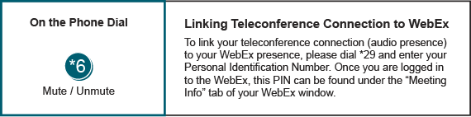
Provide feedback on the progress of this group: Facilitator Feedback Form
Visit learn.pjm.com, an easy-to-understand resource about the power industry and PJM’s role.

