Market Implementation Committee
PJM Conference & Training Center, Audubon, PA
May 2, 2018
9:00 a.m. – 4:00 p.m. EPT

Administration (9:00-9:30)
Ms. Christina Stotesbury and Ms. Chantal Hendrzak will provide announcements; review the Antitrust, Code of Conduct, and Public Meetings/Media Participation Guidelines, and Issue Tracking.

The Committee will be asked to approve the draft minutes from the April 4, 2018 MIC meeting.

Administrative Updates (9:05-9:30)
- Ms. Melissa Pilong, PJM, will provide an update on the Variable Operations and Maintenance packages that were presented as a first read at the April 19 MRC meeting.
- A representative from Monitoring Analytics will review the IMM position on VOM costs.

Endorsements/Approvals (9:30-10:20)
- Revisions to Manual 11: Energy and Ancillary Services Market Operations (9:30-10:20)
- Mr. Keyur Patel, PJM, will review conforming revisions to Manual 11 related to the FERC Order on Virtual Bidding.
- 1. Ms. Susan Kenney, PJM, will review revisions to Manual 11 to update when Generation and Load Response resources may report hourly differentiated Notification times, Minimum Run times, and Minimum Downtimes in Markets Gateway. The proposed revisions do not affect when such data is used in market clearing.
2. A representative from Monitoring Analytics will review the IMM position on these Manual 11 revisions.
- 1. Ms. Kenney, PJM, will also review conforming revisions to Manual 11 to correct certain provisions regarding price-based offers.
2. A representative from Monitoring Analytics will review the IMM position on these Manual 11 revisions.
The Committee will be asked to endorse the proposed Manual 11 revisions.

First Readings (10:20-11:10)
- Revisions to Manual 18: PJM Capacity Market (10:20-10:35)
- Mr. Jack O’Neill, PJM, will provide a first read of Manual 18 revisions associated with changes developed at the Demand Response Subcommittee (DRS) to address the Winter Peak Load (WPL) calculation problem statement assigned by the MIC in October, 2017. The Committee will be asked to endorse the manual revisions at the June MIC meeting.
- A representative from Monitoring Analytics will review the IMM position on these Manual 18 revisions.
Issue Tracking: Winter Peak Load

- FTR Nodal Remapping (10:35-10:50)
Mr. Brian Chmielewski, PJM, will review the FTR Nodal Remapping issue, and present a first read of PJM’s proposed package.
Issue Tracking: FTR Nodal Remapping

- Long Term FTR Auction (10:50-11:10)
Mr. Brian Chmielewski, PJM, will review the Long Term FTR Auction issue, and present a first read of PJM’s proposed package.
Issue Tracking: Long Term FTR Auction

Break (11:10-11:20)

Working Issues (11:20-2:00)
- FTR Forfeiture Rule (11:20-11:55)
- Ms. Sharon Midgley, Exelon, and Mike Borgatti, on behalf of NextEra Energy Resources, LLC, will present education on the FTR Forfeiture Rule issue.
- Mr. Brian Chmielewski, PJM, will review additional analysis on the FTR Forfeitures Rule and introduce a matrix. Stakeholders will be given an opportunity to identify interests and design components.
- A representative from Monitoring Analytics will present an alternate view on the issue.
Issue Tracking: FTR Forfeiture Rule Changes

- Market Seller Offer Cap Balancing Ratio (11:55-12:15)
- Mr. Pat Bruno, PJM, will continue working the Offer Cap Balancing Ratio issue, including discussion related to Net CONE x B as the default Market Seller Offer Cap, which was previously considered out of scope but approved by the MRC at the April meeting.
- A representative from Monitoring Analytics will present additional information on the issue.
Issue Tracking: Balancing Ratio Determination

Lunch (12:00-1:00)

- Must Offer Exception Process (1:00-1:20)
Mr. Pat Bruno, PJM, will provide education on the Must Offer Exception Process issue, and stakeholders will be given an opportunity to identify interests and design components.
Issue Tracking: Must Offer Exemption Process

- Quadrennial Review (1:20-2:00)
Mr. Pat Bruno, PJM, will present PJM’s preliminary recommendations in response to the Quadrennial Review.

Additional Updates (2:00-3:30)
- FERC Order 844: Uplift Cost Allocation and Transparency (2:00-2:20)
- Mr. Rami Dirani, PJM, will provide a summary of FERC Order 844, and review how it aligns with the recent Market Operations Price Transparency initiative worked within special sessions of the MIC.
Issue Tracking: Market Operations Price Transparency
- Ms. Lisa Morelli, PJM, will review the Transmission Constraint Penalty Factor component of Order 844.
Issue Tracking: Transmission Constraint Penalty Factors

- Contact Manager feature in Membership Management Community (2:20-2:30)
Ms. Suzanne Coyne, PJM, will introduce a Contact Management feature in the new Membership Management Community that will allow members to assign contacts for specific business roles.

- Fuel Assurance for Restoration (2:30-2:45)
Mr. David Schweizer, PJM, will provide a review of fuel assurance for restoration.

- Unit Specific Parameter Updates (2:45-3:00)
Ms. Susan Kenney, PJM, will provide an update on the application of Unit Specific Parameters to Base Capacity Resources starting 6/1/2018.

- Manual 11 Revisions (3:00-3:15)
Mr. Eric Endress, PJM, will provide an update on revisions to Manual 11: Energy & Ancillary Services Market Operations to address Synchronized Reserve Market Tier 1 performance. Endorsement for these manual revisions will be requested at the June OC meeting.

- MOD-026/27 Changes (3:15-3:30)
Mr. Kyle Clifford, PJM, will provide an update to ensure all generation owners are aware of upcoming changes impacting the MOD-026/27 process.

Informational Section
Credit Subcommittee (CS)
Meeting materials will be posted to the CS website.

Demand Response Subcommittee (DRS)
Meeting materials will be posted to the DRS web site.

Intermittent Resources Subcommittee (IRS)
Meeting materials will be posted to the IRS web site.

Interregional Coordination Update
Materials are posted as informational only.
Net Energy Injections Quarterly Report
Materials are posted as informational only.

Market Settlements Subcommittee (MSS)
Meeting materials are posted to the MSS web site.

Report on Market Operations
The Report on Market Operations will be reviewed during the MC Webinar.

Future Meeting Dates
June 6, 2018 | 9:00 a.m. | PJM Conference & Training Center/ WebEx
July 11, 2018 | 9:00 a.m. | PJM Conference & Training Center/ WebEx
August 8, 2018 | 9:00 a.m. | PJM Conference & Training Center/ WebEx
September 12, 2018 | 9:00 a.m. | PJM Conference & Training Center/ WebEx
October 10, 2018 | 9:00 a.m. | PJM Conference & Training Center/ WebEx
November 7, 2018 | 9:00 a.m. | PJM Conference & Training Center/ WebEx
December 12, 2018 | 9:00 a.m. | PJM Conference & Training Center/ WebEx

Author: Christina Stotesbury

Antitrust:
You may not discuss any topics that violate, or that might appear to violate, the antitrust laws including but not limited to agreements between or among competitors regarding prices, bid and offer practices, availability of service, product design, terms of sale, division of markets, allocation of customers or any other activity that might unreasonably restrain competition. If any of these items are discussed the chair will re-direct the conversation. If the conversation still persists, parties will be asked to leave the meeting or the meeting will be adjourned.

Code of Conduct:
As a mandatory condition of attendance at today's meeting, attendees agree to adhere to the PJM Code of Conduct as detailed in PJM Manual M-34 section 4.5, including, but not limited to, participants' responsibilities and rules regarding the dissemination of meeting discussion and materials.

Public Meetings/Media Participation:
Unless otherwise noted, PJM stakeholder meetings are open to the public and to members of the media. Members of the media are asked to announce their attendance at all PJM stakeholder meetings at the beginning of the meeting or at the point they join a meeting already in progress. Members of the Media are reminded that speakers at PJM meetings cannot be quoted without explicit permission from the speaker. PJM Members are reminded that "detailed transcriptional meeting notes" and white board notes from "brainstorming sessions" shall not be disseminated. Stakeholders are also not allowed to create audio, video or online recordings of PJM meetings. PJM may create audio, video or online recordings of stakeholder meetings for internal and training purposes, and your participation at such meetings indicates your consent to the same.

Participant Identification in WebEx:
When logging into the WebEx desktop client, please enter your real first and last name as well as a valid email address. Be sure to select the “call me” option.
PJM support staff continuously monitors WebEx connections during stakeholder meetings. Anonymous users or those using false usernames or emails will be dropped from the teleconference.

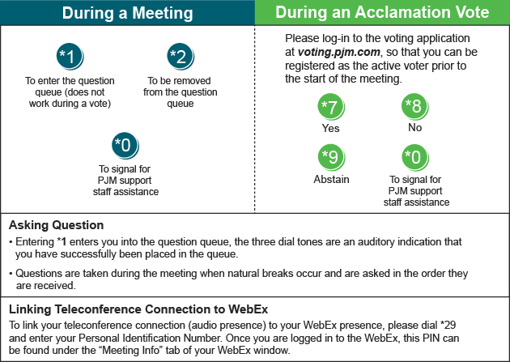

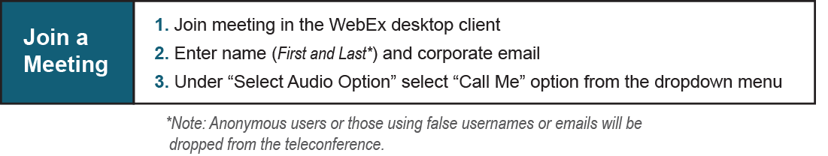
Provide feedback on the progress of this group: Facilitator Feedback Form
Visit learn.pjm.com, an easy-to-understand resource about the power industry and PJM’s role.

