Market Implementation Committee
PJM Conference & Training Center, Audubon, PA
March 6, 2019
9:00 a.m. – 1:00 p.m. EPT

Administration (9:00-9:15)
Ms. Bhavana Keshavamurthy and Ms. Chantal Hendrzak will provide announcements; review the Antitrust, Code of Conduct, Public Meetings/Media Participation, the WebEx Participant Identification Requirement, and Issue Tracking.

The Committee will be asked to approve the draft minutes from the February 6, 2019 MIC meeting.

        - Ms. Keshavamurthy, PJM, will review the MIC Work Plan.

Endorsements/Approvals (9:15-10:30)
- Load Management Testing Requirements - Problem Statement & Issue Charge (9:15-9:30)
Mr. Jack O’Neill, PJM, will present a problem statement and issue charge to address Load Management testing requirements.
The committee will be asked to approve the problem statement and issue charge.

- Updates to Location Fields in DR Hub (9:30-09:45)
Ms. Andrea Yeaton, PJM, will review updates to Manual 11 due to addition of location fields in DR Hub.
The committee will be asked to endorse the M11 changes.

- Cover to Cover Review of Manual 11 (9:45-10:00)
Ms. Susan Kenney, PJM, will review updates to Manual 11 as part of the biennial review.
The committee will be asked to endorse the M11 changes.

- Must Offer Exception Process (10:00-10:30)
        - Mr. Pat Bruno, PJM, will review the MIC endorsed proposal and the updated PJM/IMM sponsored alternate proposal for the Must Offer Exception Process.
        - Ms. Sharon Midgley, Exelon, will review the Exelon proposal.
The committee will be asked to vote on the PJM/IMM sponsored alternate proposal and the Exelon proposal. If any of the packages receives greater than 50%, a second non-binding vote will be taken asking whether participants prefer that package over the status quo and the original MIC endorsed proposal.
Issue Tracking: Must Offer Exception Process

First Readings (10:30-11:15)
- FTR Forfeiture Hourly Component (10:30-10:45)
Mr. Brian Chmielewski, PJM, will provide a first read to address an issue identified in the FTR Forfeiture hourly cost component calculations. The proposed solution will also be presented.
- Incremental Auction Revenue Rights Coordination (IARR) with MISO - Problem Statement & Issue Charge (10:45-11:00)
Mr. Brian Chmielewski, PJM, will provide a first read on a problem statement and issue charge to address an issue identified in IARR coordination with MISO.

- PJM Transmission Service and Merchant Facility Business Practices Update (11:00-11:15)
Mr. Chris Advena, PJM, will provide a first read on the revisions to the PJM Regional Business Practices document associated with the new OASIS application. The committee will be asked to endorse the changes at the April MIC. Mr. Advena will also provide an informational update on the corresponding changes to the Merchant Facilities Practices document also associated with the new OASIS.

Working Issues (11:15-11:25)
- Fuel Requirements for Black Start Resources (11:15-11:25)
Ms.Janell Fabiano, PJM, will provide a status update on the Fuel Requirements for Black Start Resources issue.
Issue Tracking: Fuel Requirements for Black Start Resources

Additional Items (11:25-12:10)
- Base Residual Auction updates (11:25-11:45)
Mr. Jeff Bastian, PJM, will review activities and associated deadlines required for Capacity Market Seller participation for the 2023/2023 Base Residual Auction.

- PJM.com Homepage Redesign(11:45-12:00)
Mr.Chad Hutchinson, PJM, will provide an update of the PJM.com homepage redesign.

- Gas Contingency Compensation - FERC Order ER19-664(12:00-12:10)
Mr. Thomas DeVita, PJM, will provide an informational update on next steps related to the FERC Order ER19-664.

Lunch (12:10-1:00)

Informational Section
Credit Subcommittee (CS)
Meeting materials will be posted to the CS website.

Demand Response Subcommittee (DRS)
Meeting materials will be posted to the DRS web site.

Intermittent Resources Subcommittee (IRS)
Meeting materials will be posted to the IRS web site.

Interregional Coordination Update
Materials are posted as informational only.

Market Settlements Subcommittee (MSS)
Meeting materials are posted to the MSS web site.

Report on Market Operations
The Report on Market Operations will be reviewed during the MC Webinar.

Future Meeting Dates
April 10, 2019 | 9:00 a.m. | PJM Conference & Training Center/ WebEx
May 15, 2019 | 9:00 a.m. | PJM Conference & Training Center/ WebEx
June 12, 2019 | 9:00 a.m. | PJM Conference & Training Center/ WebEx
July 10, 2019 | 9:00 a.m. | PJM Conference & Training Center/ WebEx
August 7, 2019 | 9:00 a.m. | PJM Conference & Training Center/ WebEx
September 11, 2019 | 9:00 a.m. | PJM Conference & Training Center/ WebEx

Author: Bhavana Keshavamurthy

Antitrust:
You may not discuss any topics that violate, or that might appear to violate, the antitrust laws including but not limited to agreements between or among competitors regarding prices, bid and offer practices, availability of service, product design, terms of sale, division of markets, allocation of customers or any other activity that might unreasonably restrain competition. If any of these items are discussed the chair will re-direct the conversation. If the conversation still persists, parties will be asked to leave the meeting or the meeting will be adjourned.

Code of Conduct:
As a mandatory condition of attendance at today's meeting, attendees agree to adhere to the PJM Code of Conduct as detailed in PJM Manual M-34 section 4.5, including, but not limited to, participants' responsibilities and rules regarding the dissemination of meeting discussion and materials.

Public Meetings/Media Participation:
Unless otherwise noted, PJM stakeholder meetings are open to the public and to members of the media. Members of the media are asked to announce their attendance at all PJM stakeholder meetings at the beginning of the meeting or at the point they join a meeting already in progress. Members of the Media are reminded that speakers at PJM meetings cannot be quoted without explicit permission from the speaker. PJM Members are reminded that "detailed transcriptional meeting notes" and white board notes from "brainstorming sessions" shall not be disseminated. Stakeholders are also not allowed to create audio, video or online recordings of PJM meetings. PJM may create audio, video or online recordings of stakeholder meetings for internal and training purposes, and your participation at such meetings indicates your consent to the same.

Participant Identification in WebEx:
When logging into the WebEx desktop client, please enter your real first and last name as well as a valid email address. Be sure to select the “call me” option.
PJM support staff continuously monitors WebEx connections during stakeholder meetings. Anonymous users or those using false usernames or emails will be dropped from the teleconference.

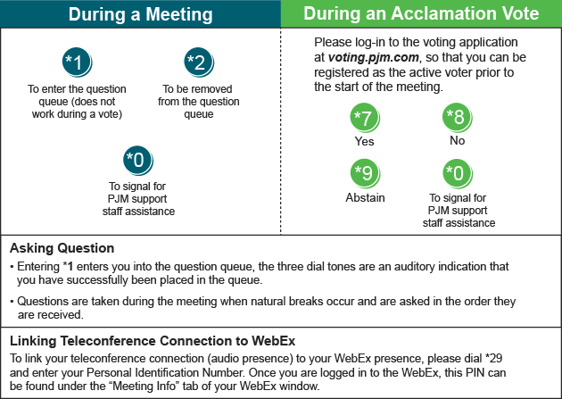

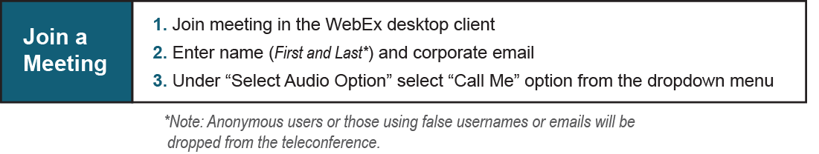

Provide feedback on the progress of this group: Facilitator Feedback Form
Visit learn.pjm.com, an easy-to-understand resource about the power industry and PJM’s role.

