MIC Special Session - Five Minute Dispatch and Pricing
PJM Conference and Training Center
October 2, 2019
1:00 p.m. – 4:00 p.m. EPT

Administration (1:00-1:10)
Ms. Lisa Morelli and Ms. Alexandra Scheirer will provide welcome, announcements and review of the Antitrust, Code of Conduct, and Public Meetings/Media Participation Guidelines.
Ms. Alexandra Scheirer will make announcement regarding the PJM Stakeholder Survey
  - The Stakeholder Survey is open through October 11, 2019

Alignment of Dispatch and Pricing (1:10-3:15)
- Alignment of Dispatch and Pricing (1:10 – 3:15)
  - Alignment of Dispatch and Pricing Issue Education (1:10 – 3:00) – Ms. Catherine Tyler, Monitoring Analytics, will present additional education on the issues identified with the alignment of five-minute dispatch and pricing intervals and impacts in markets.
  - Interest Identification (3:00 – 3:15) – Ms. Lisa Morelli, PJM, will lead the group in beginning the Consensus Based Issue Resolution process. The committee will be asked to provide interests around the alignment of five-minute dispatch and pricing. For further information about this step in the CBIR process, please refer to Manual 34, Section 7.2

Price Transparency (3:15-4:00)
- Price Transparency during Off SCED Periods and Price Bounding Events (3:15 – 4:00) – Mr. Vijay Shah, PJM, will provide education on how LMP verification is performed for periods when PJM is dispatching off of SCED control. Education on the April 2019 price bounding event and its impacts on price transparency will also be presented.

Future Agenda Items (0:00)

Future Meeting Dates
November 25, 2019 | 1:00 p.m. – 4:00 p.m. | PJM Conference & Training Center/ WebEx
December 13, 2019 | 1:00 p.m. – 4:00 p.m. | PJM Conference & Training Center/ WebEx

Author: Alexandra Scheirer

Antitrust:
You may not discuss any topics that violate, or that might appear to violate, the antitrust laws including but not limited to agreements between or among competitors regarding prices, bid and offer practices, availability of service, product design, terms of sale, division of markets, allocation of customers or any other activity that might unreasonably restrain competition. If any of these items are discussed the chair will re-direct the conversation. If the conversation still persists, parties will be asked to leave the meeting or the meeting will be adjourned.

Code of Conduct:
As a mandatory condition of attendance at today's meeting, attendees agree to adhere to the PJM Code of Conduct as detailed in PJM Manual M-34 section 4.5, including, but not limited to, participants' responsibilities and rules regarding the dissemination of meeting discussion and materials.

Public Meetings/Media Participation:
Unless otherwise noted, PJM stakeholder meetings are open to the public and to members of the media. Members of the media are asked to announce their attendance at all PJM stakeholder meetings at the beginning of the meeting or at the point they join a meeting already in progress. Members of the Media are reminded that speakers at PJM meetings cannot be quoted without explicit permission from the speaker. PJM Members are reminded that "detailed transcriptional meeting notes" and white board notes from "brainstorming sessions" shall not be disseminated. Stakeholders are also not allowed to create audio, video or online recordings of PJM meetings. PJM may create audio, video or online recordings of stakeholder meetings for internal and training purposes, and your participation at such meetings indicates your consent to the same.
Participant Identification in WebEx:
When logging into the WebEx desktop client, please enter your real first and last name as well as a valid email address. Be sure to select the “call me” option.
PJM support staff continuously monitors WebEx connections during stakeholder meetings. Anonymous users or those using false usernames or emails will be dropped from the teleconference.



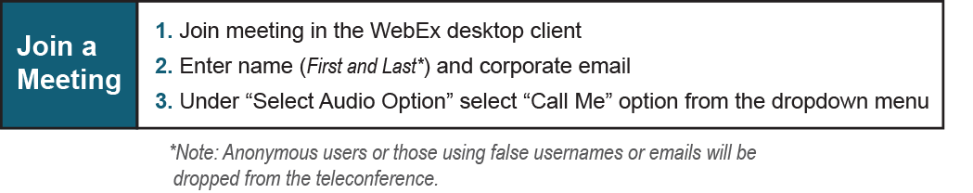

Provide feedback on the progress of this group: Facilitator Feedback Form
Visit learn.pjm.com, an easy-to-understand resource about the power industry and PJM’s role.

