Market Implementation Committee
PJM Conference & Training Center, Audubon, PA
October 16, 2019
9:00 a.m. – 4:00 p.m. EPT

Administration (9:00-9:30)
Ms. Bhavana Keshavamurthy and Ms. Lisa Morelli will provide announcements; review the Antitrust, Code of Conduct, Public Meetings/Media Participation, the WebEx Participant Identification Requirement, and Issue Tracking.

The Committee will be asked to approve the draft minutes from the September 11, 2019 Market Implementation Committee meeting.
        - Ms. Rebecca Carroll, PJM, will provide an update on the Performance Assessment Interval (PAI) event that occurred on October 2, 2019.

Endorsements/Approvals (9:30-10:30)
      - ARR/FTR Market Review (9:30-10:15)
        - Mr. Howard Haas, Monitoring Analytics, will present the problem statement and issue charge related to the review of the ARR/FTR Market construct.
        - Mr. Mike Borgatti, Gabel Associates, will present an alternate issue charge related to the review of the ARR/FTR Market construct.
        - Mr. Roy Shankar, representing the Financial Marketers Coalition, will present an alternate issue charge related to the review of the AR/FTR Market construct.
The committee will be asked to vote on all the issue charges.

      - Interregional Incremental Auction Revenue Rights (10:15-10:30)
Mr. Brian Chmielewski, PJM, will request a vote to close this issue charge. PJM recommends Status Quo absent feedback from stakeholders.
Issue Tracking: Interregional Incremental Auction Revenue Rights
The committee will be asked to vote to close this issue charge.

First Readings (10:30-11:00)
- Manual 18 revisions related to the RPM Must-Offer Exception Process (10:30-10:45)
Mr. Pat Bruno, PJM, will review conforming revisions to Manual 18: PJM Capacity Market related to the recent FERC Order (ER19-2417) on RPM must-offer exceptions and removal of Capacity Resource status.
The committee will be asked to endorse the manual revisions at the November MIC.

- Manual 15 revisions related to VOM Compliance Filing(10:45-11:00)
Mr. Thomas Hauske will review conforming revisions to Manual 15: Cost Development Guidelines consistent with the May 10, 2019 VOM Compliance Filing that was recently accepted by FERC.
The committee will be asked to endorse the manual revisions at the November MIC.

Working Items (11:00-11:45)
- Stability Limits in Markets and Operations (11:00-11:45)
Mr. Liem Hoang, PJM, and Mr. Michael Zhang, PJM, will provide education on Modeling Units with Stability Limitations.
Stability Limits in Markets and Operations

Additional Updates (11:45-1:00)
- Load Reconciliation Settlement Process (11:45-12:05)
Mr. Ray Fernandez, PJM, will update the committee on a problem statement and issue charge on the load reconciliation settlement process that will be worked on at the Market Settlements Subcommittee.

- Communication & Subscription Improvements (12:05-12:10)
Ms. Monica Burkett, PJM, will provide an update on the PJM communication/subscription tool.

- Extended Winter Outages (12:10-12:15)
Mr. Dean Manno, PJM, will provide an informational update on extended transmission outages scheduled to occur over the winter peak period.

Lunch (12:15-1:00)

Informational Section
Credit Subcommittee (CS)
Meeting materials will be posted to the CS website.

Demand Response Subcommittee (DRS)
Meeting materials will be posted to the DRS web site.

Intermittent Resources Subcommittee (IRS)
Meeting materials will be posted to the IRS web site.

Market Settlements Subcommittee (MSS)
Meeting materials are posted to the MSS web site.

Report on Market Operations
The Report on Market Operations will be reviewed during the MC Webinar.

Interregional Coordination Update
Materials are posted as informational only.

CP Unit Specific Parameter Update
Materials are posted as informational only.

Manual 3 updates
Materials are posted as informational only.

Future Meeting Dates
November 13, 2019 | 9:00 a.m. | PJM Conference & Training Center/ WebEx
December 11, 2019 | 9:00 a.m. | PJM Conference & Training Center/ WebEx

Author: Bhavana Keshavamurthy

Antitrust:
You may not discuss any topics that violate, or that might appear to violate, the antitrust laws including but not limited to agreements between or among competitors regarding prices, bid and offer practices, availability of service, product design, terms of sale, division of markets, allocation of customers or any other activity that might unreasonably restrain competition. If any of these items are discussed the chair will re-direct the conversation. If the conversation still persists, parties will be asked to leave the meeting or the meeting will be adjourned.

Code of Conduct:
As a mandatory condition of attendance at today's meeting, attendees agree to adhere to the PJM Code of Conduct as detailed in PJM Manual M-34 section 4.5, including, but not limited to, participants' responsibilities and rules regarding the dissemination of meeting discussion and materials.

Public Meetings/Media Participation:
Unless otherwise noted, PJM stakeholder meetings are open to the public and to members of the media. Members of the media are asked to announce their attendance at all PJM stakeholder meetings at the beginning of the meeting or at the point they join a meeting already in progress. Members of the Media are reminded that speakers at PJM meetings cannot be quoted without explicit permission from the speaker. PJM Members are reminded that "detailed transcriptional meeting notes" and white board notes from "brainstorming sessions" shall not be disseminated. Stakeholders are also not allowed to create audio, video or online recordings of PJM meetings. PJM may create audio, video or online recordings of stakeholder meetings for internal and training purposes, and your participation at such meetings indicates your consent to the same.

Participant Identification in WebEx:
When logging into the WebEx desktop client, please enter your real first and last name as well as a valid email address. Be sure to select the “call me” option.
PJM support staff continuously monitors WebEx connections during stakeholder meetings. Anonymous users or those using false usernames or emails will be dropped from the teleconference.

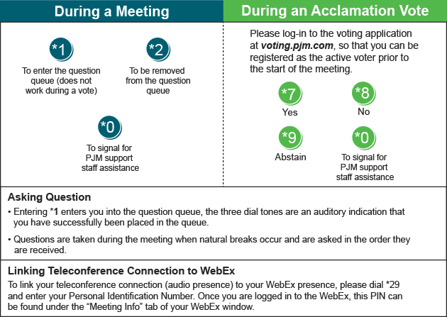

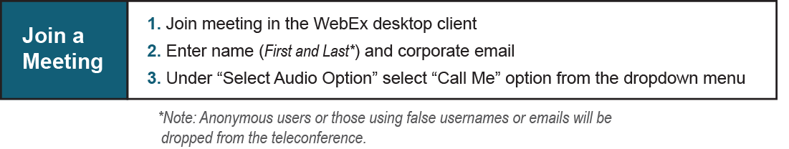

Provide feedback on the progress of this group: Facilitator Feedback Form
Visit learn.pjm.com, an easy-to-understand resource about the power industry and PJM’s role.

