Market Implementation Committee
WebEx Only
May 13, 2020
9:00 a.m. – 4:00 p.m. EPT

Administration (9:00-9:05)
Ms. Bhavana Keshavamurthy will review the Antitrust, Code of Conduct, Public Meetings/Media Participation and the WebEx Participant Identification Requirements.

The Committee will be asked to approve the draft minutes from the Apr.15, 2020 Market Implementation Committee meeting.

Endorsements/Approvals (9:05-9:30)
- Manual 18 revisions related to Price Responsive Demand (9:05-9:15)
Ms. Terri Esterly will review conforming revisions to Manual 18: PJM Capacity Market related to Price Responsive Demand.
The committee will be asked to endorse the manual revisions at this meeting.

- PMA Credit Requirements for NITS Charges (9:15-9:30)
Ms. Bridgid Cummings will review the Problem Statement and Issue Charge addressing the Peak Market Activity (PMA) credit requirements pertaining to state law transfer of charges or credits.
The committee will be asked to approve the issue charge and endorse the solution at this meeting.

First Readings (9:30-10:30)
- Five Minute Dispatch and Pricing (9:30-10:15)
- Mr. Vijay Shah will provide a first read of the PJM proposal addressing the Five Minute Dispatch and Pricing Issue Charge.
- Ms. Rebecca Carroll will provide a timeline for the PJM Intermediate solution
- Ms. Catherine Tyler, Monitoring Analytics will review the IMM proposal.
Issue Tracking: Five Minute Dispatch and Pricing

- Manual 6 revisions(10:15-10:30)
Ms. Emmy Messina will review updates to Manual 6: Financial Transmission Rights as part of the periodic review. All changes are administrative in nature, including clarifications, grammar, punctuation, capitalization and spacing changes throughout the manual.

Working Items (10:30-11:15)
- Stability Limits in Markets and Operations (10:30-11:15)
- Mr. Joe Ciabattoni will provide an update on PJM’s position and provide additional education.
- Ms. Catherine Tyler, Monitoring Analytics will review the capacity constraint joint package.
- Ms. Lisa Morelli will solicit feedback and facilitate the discussion on packages based on stakeholder input. Additional solution options and packages can be provided in advance of the meeting or during the meeting.
Issue Tracking: Stability Limits in Markets and Operations

Additional Items (11:15-12:15)
- XO Energy FTR Forfeiture Rule Complaint (11:15-11:25)
Mr. Thomas DeVita will provide an update on PJM’s response to the FTR Forfeiture rule complaint by XO Energy.

- Radford’s Run FERC order update (11:25-11:40)
Ms. Susan McGill will provide an overview of FERC’s order EL18-183 to grant ICTRs to Radford’s Run retroactively to June 1, 2019.

- Fuel Cost Policy Annual Review (11:40-11:50)
Ms. Gabby Genuario will provide an overview of the Fuel Cost Policy deadlines for the upcoming annual review.

- ARR FTR Market Task Force Update (11:50-12:00)
Mr. Dave Anders will provide an update on Recommendation F3 of the Report of the Independent Consultants on the GreenHat Default as it relates to the ARR FTR Market Task Force.

- FERC Transmission Orders Requiring Reallocations and Refunds(12:00-12:15)
Mr. Ray Fernandez will discuss cost allocation issues associated with multiple orders from FERC that require resettlement.

Lunch (12:15-1:00)
- Minimum Offer Price Rule Update (1:00-4:00)
PJM staff will provide an overview of the FERC order on requests for rehearing and clarification in the MOPR docket and discuss the impacts to PJM’s March 2020 compliance filing.

Informational Section
Interface Pricing Points Update
This presentation provides an overview of updates being made to Interface Pricing Points. Materials are posted as informational only.

Interregional Coordination Update
Materials are posted as informational only.

Q12020 Net Energy Injections Quarterly Report
Materials are posted as informational only.

Credit Subcommittee (CS)
Meeting materials will be posted to the CS website.

Demand Response Subcommittee (DRS)
Meeting materials will be posted to the DRS web site.

Intermittent Resources Subcommittee (IRS)
Meeting materials will be posted to the IRS web site.

Market Settlements Subcommittee (MSS)
Meeting materials are posted to the MSS web site.

Report on Market Operations
The Report on Market Operations will be reviewed during the MC Webinar.

Future Meeting Dates
June 3, 2020 | 9:00 a.m. | PJM Conference & Training Center/ WebEx
July 8, 2020 | 9:00 a.m. | PJM Conference & Training Center/ WebEx
August 5, 2020 | 9:00 a.m. | PJM Conference & Training Center/ WebEx
September 2, 2020 | 9:00 a.m. | PJM Conference & Training Center/ WebEx
Author: Bhavana Keshavamurthy

Antitrust:
You may not discuss any topics that violate, or that might appear to violate, the antitrust laws including but not limited to agreements between or among competitors regarding prices, bid and offer practices, availability of service, product design, terms of sale, division of markets, allocation of customers or any other activity that might unreasonably restrain competition. If any of these items are discussed the chair will re-direct the conversation. If the conversation still persists, parties will be asked to leave the meeting or the meeting will be adjourned.

Code of Conduct:
As a mandatory condition of attendance at today's meeting, attendees agree to adhere to the PJM Code of Conduct as detailed in PJM Manual M-34 section 4.5, including, but not limited to, participants' responsibilities and rules regarding the dissemination of meeting discussion and materials.

Public Meetings/Media Participation:
Unless otherwise noted, PJM stakeholder meetings are open to the public and to members of the media. Members of the media are asked to announce their attendance at all PJM stakeholder meetings at the beginning of the meeting or at the point they join a meeting already in progress. Members of the Media are reminded that speakers at PJM meetings cannot be quoted without explicit permission from the speaker. PJM Members are reminded that "detailed transcriptional meeting notes" and white board notes from "brainstorming sessions" shall not be disseminated. Stakeholders are also not allowed to create audio, video or online recordings of PJM meetings. PJM may create audio, video or online recordings of stakeholder meetings for internal and training purposes, and your participation at such meetings indicates your consent to the same.
Participant Identification in WebEx:
When logging into the WebEx desktop client, please enter your real first and last name as well as a valid email address. Be sure to select the “call me” option.
PJM support staff continuously monitors WebEx connections during stakeholder meetings. Anonymous users or those using false usernames or emails will be dropped from the teleconference.

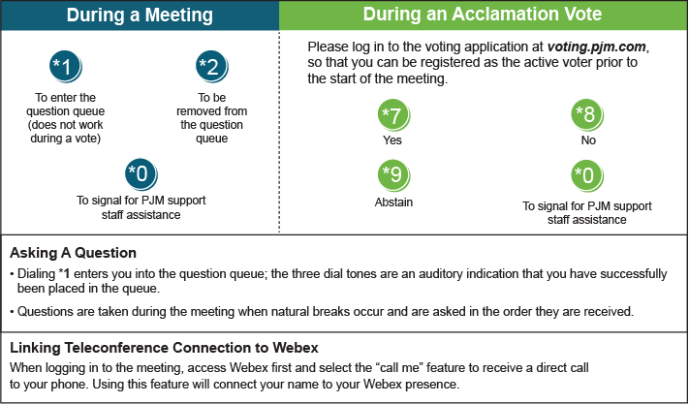

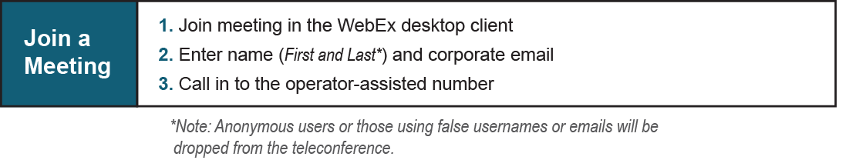
Provide feedback on the progress of this group: Facilitator Feedback Form
Visit learn.pjm.com, an easy-to-understand resource about the power industry and PJM’s role.

