Market Implementation Committee
WebEx Only
December 2, 2020
9:00 a.m. – 4:00 p.m. EPT

Administration (9:00-9:05)
Nicholas DiSciullo will review the Antitrust, Code of Conduct, Public Meetings/Media Participation and the WebEx Participant Identification Requirements.

The Committee will be asked to approve the draft minutes from the November 5, 2020 Market Implementation Committee meeting.

Endorsements/Approvals (9:05 – 9:40)
- Manual 6: FTR Bid Limits Changes (9:05 – 9:20)
Brian Chmielewski will provide an overview of updates to Manual 6: Financial Transmission Rights. The changes address the enforcement of FTR Bid Limits at the corporate entity level.
The committee will be asked to endorse the Manual 6 revisions at this meeting.

- Manual 11 and Manual 18: Public Distribution Microgrids Changes (9:20 – 9:30)
Natalie Tacka will provide an overview of updates to Manual 11: Energy & Ancillary Services Market Operations and Manual 18: PJM Capacity Market.
The committee will be asked to endorse the Manual 11 and Manual 18 revisions at this meeting.

- Manual 28: UTC Uplift Changes (9:30 – 9:40)
Ray Fernandez will provide an overview of updates to Manual 28: Operating Agreement Accounting conforming with the changes directed in FERC Order EL-14-37-000. The changes address the allocation of real-time uplift and day-ahead uplift to UTCs.
The committee will be asked to endorse the Manual 28 revisions at this meeting.

Additional Items – Part 1 (9:40 – 10:10)
- Minimum Offer Price Rule / Base Residual Auction Schedule (9:40 – 10:10)
- Pete Langbein will provide an update on the 2022/2023 Base Residual Auction process and timelines.
- Asim Haque will provide an overview of MOPR applicability to Default Service Auctions.
Issue Tracking: Capacity Market Minimum Offer Price Rule (MOPR) Order

First Readings (10:10 – 10:45)
- Manual 18: Minimum Offer Price Rule Changes (10:10 – 10:30)
Jeff Bastian will provide a first read of updates to Manual 18: PJM Capacity Market. These changes conform with the FERC-ordered rule changes in the Minimum Offer Price Rule and Forward Energy & Ancillary Services Offset dockets (Docket Nos. EL16-49-003, EL18-178-003, ER18- 1314-006 and EL19-58). The committee will be asked to endorse these changes at the January MIC meeting.
Issue Tracking: Capacity Market Minimum Offer Price Rule (MOPR) Order

- PRD Credits Disposition (10:30 – 10:45)
David Bloom, BGE, will provide a first read of the BGE proposal addressing the PRD Credits Disposition issue.
The committee will be asked to endorse the proposal at the January MIC meeting.
Issue Tracking: Price Responsive Demand (PRD) Credits Disposition

Working Items (10:45 - 1:30)
- Behind the Meter Generation Business Rules on Status Changes (10:45 – 12:00)
Terri Esterly will provide education on the existing Behind the Meter Generation rules on status changes.
Issue Tracking: Behind the Meter Generation Business Rules on Status Changes

Lunch (12:00 - 12:30)
- Market Suspension (12:30 – 1:30)
Lisa Morelli will facilitate a discussion on the Market Suspension matrix. Additional interests, design components, and solution options can be provided in advance of the meeting or during the meeting.
Issue Tracking: Rules Related to Market Suspension

Additional Items – Part 2 (1:30 – 2:15)
- Stability Limits in Markets and Operations (1:30 – 2:00)
Joe Ciabattoni will review proposed updates to Manual 3: Transmission Operations, Manual 11: Energy & Ancillary Services Market Operations, Manual 28: Operating Agreement Accounting, and proposed Operating Agreement revisions to reflect the Capacity Constraint and Opportunity Cost packages, which were endorsed at the September MIC.
Issue Tracking: Stability Limits in Markets and Operations

- Emergency Procedures (2:00 – 2:10)
Chidi Ofoegbu will provide an update on upcoming enhancements to the Emergency Procedures application, highlighting Performance Assessment Interval (PAI) and user profile updates.

- Emerging Technologies Forum (2:10 – 2:15)
Natasha Holter will provide an update on the Emerging Technologies Forum.

Informational Section
CP Unit Specific Parameter Update
Materials are posted as informational only.

Interregional Coordination Update
Materials are posted as informational only.

Credit Subcommittee (CS)
Meeting materials are posted to the CS website.

Demand Response Subcommittee (DRS)
Meeting materials are posted to the DRS website.

DER & Inverter-based Resources Subcommittee (DIRS)
Meeting materials are posted to the DIRS website.

Market Settlements Subcommittee (MSS)
Meeting materials are posted to the MSS website.

Report on Market Operations
The Report on Market Operations will be reviewed during the MC Webinar.

Future Meeting Dates
January 12, 2021 | 9:00 a.m. | WebEx
February 10, 2021 | 9:00 a.m. | WebEx
March 10, 2021 | 9:00 a.m. | WebEx
April 7, 2021 | 9:00 a.m. | WebEx
May 13, 2021 | 9:00 a.m. | WebEx
June 9, 2021 | 9:00 a.m. | WebEx
July 14, 2021 | 9:00 a.m. | WebEx
August 11, 2021 | 9:00 a.m. | WebEx
September 9, 2021 | 9:00 a.m. | WebEx
October 6, 2021 | 9:00 a.m. | WebEx
November 3, 2021 | 9:00 a.m. | WebEx
December 1, 2021 | 9:00 a.m. | WebEx

Author: Nick DiSciullo

Antitrust:
You may not discuss any topics that violate, or that might appear to violate, the antitrust laws including but not limited to agreements between or among competitors regarding prices, bid and offer practices, availability of service, product design, terms of sale, division of markets, allocation of customers or any other activity that might unreasonably restrain competition. If any of these items are discussed the chair will re-direct the conversation. If the conversation still persists, parties will be asked to leave the meeting or the meeting will be adjourned.

Code of Conduct:
As a mandatory condition of attendance at today's meeting, attendees agree to adhere to the PJM Code of Conduct as detailed in PJM Manual M-34 section 4.5, including, but not limited to, participants' responsibilities and rules regarding the dissemination of meeting discussion and materials.

Public Meetings/Media Participation:
Unless otherwise noted, PJM stakeholder meetings are open to the public and to members of the media. Members of the media are asked to announce their attendance at all PJM stakeholder meetings at the beginning of the meeting or at the point they join a meeting already in progress. Members of the Media are reminded that speakers at PJM meetings cannot be quoted without explicit permission from the speaker. PJM Members are reminded that "detailed transcriptional meeting notes" and white board notes from "brainstorming sessions" shall not be disseminated. Stakeholders are also not allowed to create audio, video or online recordings of PJM meetings. PJM may create audio, video or online recordings of stakeholder meetings for internal and training purposes, and your participation at such meetings indicates your consent to the same.
Participant Identification in WebEx:
When logging into the WebEx desktop client, please enter your real first and last name as well as a valid email address. Be sure to select the “call me” option.
PJM support staff continuously monitors WebEx connections during stakeholder meetings. Anonymous users or those using false usernames or emails will be dropped from the teleconference.
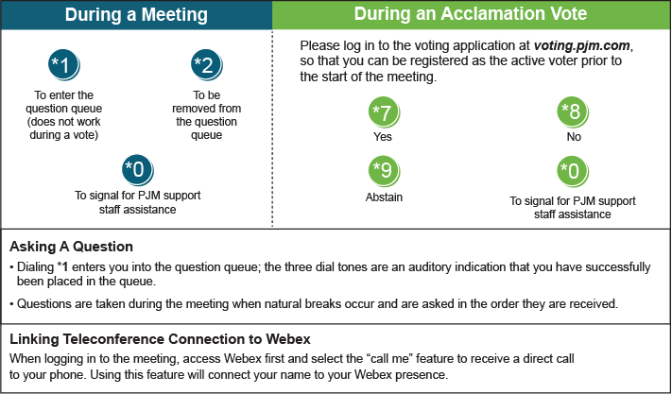

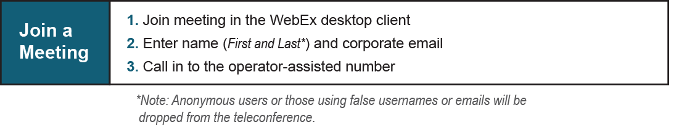
Provide feedback on the progress of this group: Facilitator Feedback Form
Visit learn.pjm.com, an easy-to-understand resource about the power industry and PJM’s role.

