Market Implementation Committee

WebEx / Conference & Training Center

August 10, 2022

9:00 a.m. – 3:10 p.m. EPT

Administration (9:00 – 9:10)

Nicholas DiSciullo will review the Antitrust, Code of Conduct, Public Meetings/Media Participation and the WebEx Participant Identification Requirements.

The Committee will be asked to approve the draft minutes from the July 13, 2022 Market Implementation Committee.

1. Nicholas DiSciullo will review the MIC Work Plan.

Endorsements/Approvals (9:10 – 9:40)

1. **Manual 15 Revisions: Reserve Price Formation (9:10 – 9:25)**

Ilyana Dropkin will review conforming revisions to Manual 15: Cost Development Guidelines to address the Reserve Price Formation implementation.

The committee will be asked to endorse the Manual 15 revisions at this meeting.

[Issue Tracking: Energy Price Formation](https://www.pjm.com/committees-and-groups/issue-tracking/issue-tracking-details.aspx?Issue=9adc71ec-e467-4c91-8239-79ed6a865ea0)

1. **Day-ahead Zonal Load Bus Distribution Factors (9:25 – 9:40)**

Amanda Martin will review a Problem Statement and Issue Charge addressing Day-ahead Zonal Load Bus Distribution Factors.

**The committee will be asked to approve the Issue Charge as part of the “CBIR Lite” process outlined in Section 8.6.2 of Manual 34 at this meeting.**

First Readings (9:40 – 12:30)

1. **Fuel Requirements for Black Start Resources (9:40 – 10:20)**
   1. Janell Fabiano will provide background, polling results, and an overview of the voting process for this issue.
   2. Dan Bennett will review the PJM/Brookfield/DC OPC proposal
   3. Joe Bowring, IMM, will review the IMM proposal.
2. **Variable Operations & Maintenance Cost Development (10:20 – 10:50)**
   1. Roger Cao will provide a first read of the PJM proposal addressing development of variable operations and maintenance costs that was developed through the Cost Development Subcommittee.
   2. Jason Barker, Constellation, will provide a first read of the Constellation proposal addressing development of variable operations and maintenance costs that was developed through the Cost Development Subcommittee.

The committee will be asked to vote on the proposals at its next meeting.

1. **Residential and Small Commercial Customer Measurement and Verification for Demand Response (10:50 – 11:10)**

Ken Schisler, CPower, will provide a first read of a Problem Statement and Issue Charge addressing Residential and Small Commercial Customer Measurement and Verification for Demand Response. The committee will be asked to approve the Issue Charge at its next meeting.

1. **Manual 18 and Manual 18B Revisions (11:10 – 11:30)**

Theresa Esterly will review revisions to Manual 18: PJM Capacity Market, and Manual 18B: Energy Efficiency Measurement & Verification as part of the periodic review. The committee will be asked to endorse the revisions at its next meeting.

1. **Reserve Price Formation Manual Revisions (11:30 – 12:30)**
   1. Rebecca Stadelmeyer will provide a first read of conforming revisions to Manual 27: Open Access Transmission Tariff Accounting, Manual 28: Operating Agreement Accounting, and Manual 29: Billing to address the Reserve Price Formation implementation.
   2. Damon Fereshetian and Michael Olaleye will provide a first read of conforming revisions to Manual 11: Energy & Ancillary Services Market Operations to address the Reserve Price Formation implementation.

The committee will be asked to endorse the revisions at its next meeting.

[Issue Tracking: Energy Price Formation](https://www.pjm.com/committees-and-groups/issue-tracking/issue-tracking-details.aspx?Issue=9adc71ec-e467-4c91-8239-79ed6a865ea0)

Lunch (12:30 – 1:30)

Working Items (1:30 – 3:00)

1. **Capacity Offer Opportunities for Generation with Co-Located Load (1:30 – 2:30)**

Lisa Morelli will facilitate a discussion to review packages for the Capacity Offer Opportunities for Generation with Co-Located Load matrix. Additional packages can be provided in advance of the meeting or during the meeting.

[Issue Tracking: Capacity Offer Opportunities for Generation with Co-Located Load](https://www.pjm.com/committees-and-groups/issue-tracking/issue-tracking-details.aspx?Issue=6897c7e7-d8b7-438e-9e3f-b6099f9dd7ec)

1. **Operating Reserve Clarification for Resources Operating as Requested by PJM (2:30 – 3:00)**

Lisa Morelli will review a proposal to proceed with removal of the CT Rule in Manual 28 in advance of the remainder of the work on this issue charge. Nick DiSciullo will solicit committee feedback on addressing the remaining work on this issue through special sessions of the MIC.

[Issue Tracking: Operating Reserve Clarification for Resources Operating as Requested by PJM](https://www.pjm.com/committees-and-groups/issue-tracking/issue-tracking-details.aspx?Issue=6897c7e7-d8b7-438e-9e3f-b6099f9dd7ec)

Additional Items (3:00 – 3:10)

1. Cost Development Subcommittee Update (3:00 – 3:05)

Heather Reiter will provide an informational update on the work to be performed at the Cost Development Subcommittee.

1. **Regulation Market Design Senior Task Force Update (3:05 – 3:10)**

Michael Herman will provide an informational update on the efforts of the Regulation Market Design Senior Task Force.

Informational Section

**Fast Start Pricing Monthly Metrics Update**

Materials are posted as informational only.

**Interregional Coordination Update**

Materials are posted as informational only.

**PJM Net Energy Injections Quarterly Review**

Materials are posted as informational only.

**Stability Limits in Markets and Operations**

Materials are posted as informational only.

**ARR FTR Market Task Force (AFMTF)**   
Meeting materials are posted to the [AFMTF website](https://www.pjm.com/committees-and-groups/task-forces/afmtf).

**Regulation Market Design Senior Task Force (RMDSTF)**

Meeting materials are posted to the [RMDSTF website](https://www.pjm.com/committees-and-groups/task-forces/rmdstf).

**Reactive Power Compensation Task Force (RPCTF)**   
Meeting materials are posted to the [RPCTF website.](https://www.pjm.com/committees-and-groups/task-forces/rpctf)

**Cost Development Subcommittee (CDS)**   
Meeting materials are posted to the [CDS website](https://www.pjm.com/committees-and-groups/subcommittees/cds).

**Demand Response Subcommittee (DRS)**   
Meeting materials are posted to the [DRS website](http://www.pjm.com/committees-and-groups/subcommittees/drs.aspx).

**DER & Inverter-based Resources Subcommittee (DIRS)**

Meeting materials are posted to the [DIRS website.](https://www.pjm.com/committees-and-groups/subcommittees/dirs.aspx)

**Market Settlements Subcommittee (MSS)**

Meeting materials are posted to the [MSS website](http://www.pjm.com/committees-and-groups/subcommittees/mss.aspx).

OC/MIC Fuel Requirements for Black Start Resources

Meeting materials are posted to the [Operating Committee website](https://www.pjm.com/committees-and-groups/committees/oc).

Report on Market Operations

The Report on Market Operations will be reviewed during the [MC Webinar](http://www.pjm.com/committees-and-groups/committees/mc.aspx).

|  |  |  |  |  |
| --- | --- | --- | --- | --- |
| **Future Meeting Dates and Materials** | | | **Materials Due  to Secretary** | **Materials Published** |
| Date | Time | Location | 5 p.m. | 4 p.m. |
| September 7 | 9 a.m. | WebEx / Conference & Training Center | August 26 | August 31 |
| October 6 | 9 a.m. | WebEx / Conference & Training Center | September 26 | September 29 |
| November 2 | 9 a.m. | WebEx / Conference & Training Center | October 21 | October 26 |
| December 7 | 9 a.m. | WebEx / Conference & Training Center | November 23 | November 30 |

Author: Nick DiSciullo

Antitrust:

You may not discuss any topics that violate, or that might appear to violate, the antitrust laws including but not limited to agreements between or among competitors regarding prices, bid and offer practices, availability of service, product design, terms of sale, division of markets, allocation of customers or any other activity that might unreasonably restrain competition. If any of these items are discussed the chair will re-direct the conversation. If the conversation still persists, parties will be asked to leave the meeting or the meeting will be adjourned.

Code of Conduct:

As a mandatory condition of attendance at today's meeting, attendees agree to adhere to the PJM Code of Conduct as detailed in PJM Manual M-34 section 4.5, including, but not limited to, participants' responsibilities and rules regarding the dissemination of meeting discussion and materials.

Public Meetings/Media Participation:

Unless otherwise noted, PJM stakeholder meetings are open to the public and to members of the media. Members of the media are asked to announce their attendance at all PJM stakeholder meetings at the beginning of the meeting or at the point they join a meeting already in progress. Members of the Media are reminded that speakers at PJM meetings cannot be quoted without explicit permission from the speaker. PJM Members are reminded that "detailed transcriptional meeting notes" and white board notes from "brainstorming sessions" shall not be disseminated. Stakeholders are also not allowed to create audio, video or online recordings of PJM meetings. PJM may create audio, video or online recordings of stakeholder meetings for internal and training purposes, and your participation at such meetings indicates your consent to the same.

Participant Identification in WebEx:

When logging into the WebEx desktop client, please enter your real first and last name as well as a valid email address. Be sure to select the “call me” option.

PJM support staff continuously monitors WebEx connections during stakeholder meetings. Anonymous users or those using false usernames or emails will be dropped from the teleconference.

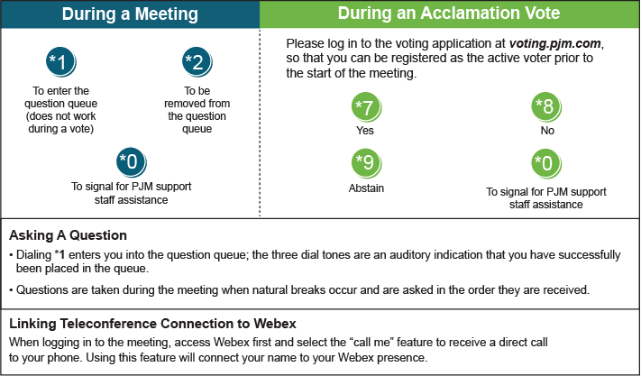

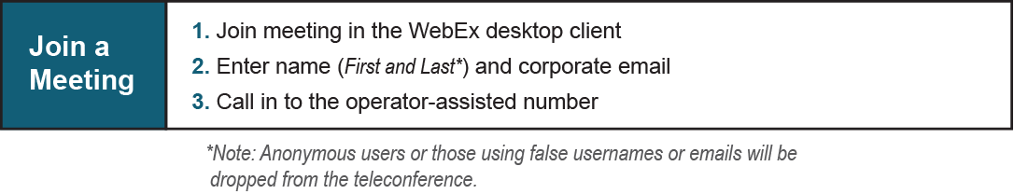

Provide feedback on the progress of this group: [*Facilitator Feedback Form*](https://www.pjm.com/committees-and-groups/committees/form-facilitator-feedback.aspx)   
Visit [*learn.pjm.com*](https://learn.pjm.com/), an easy-to-understand resource about the power industry and PJM’s role.