Markets and Reliability Committee
Webex Only
May 28, 2020
9:00 a.m. – 12:55 p.m.
*Operator assisted phone lines will be opened 30 minutes prior to the start of the meeting. Due to the high volume of remote participation, stakeholders are asked to connect early to allow additional time for operator queue processing.

Administration (9:00-9:05)
Welcome, announcements and Anti-trust, Code of Conduct, and Public Meetings/Media Participation – Stu Bresler and Dave Anders

Consent Agenda (9:05-9:10)
- Approve minutes of the April 30, 2020 meeting of the Markets and Reliability Committee (MRC).
- Endorse proposed revisions to PJM Manual 01: Control Center and Data Exchange including revisions to Attachment A: Data Specification and Collection Attachment B: Schedule of Data Submittals.
- Endorse proposed revisions to Manual 03: Transmission Operations and a proposed Manual 03B related to CEII.
- Endorse proposed revisions to PJM Manual 03: Transmission Operations resulting from the bi-annual review to update operating procedures.
- Endorse conforming revisions to Manual 18: PJM Capacity Market related to Price Responsive Demand.
- Endorse proposed revisions to PJM Manual 36: System Restoration including revisions to Attachment B: Restoration Forms and Attachment G: Coordination of Restoration Plan with PJM Internal and External Neighboring Entities - PJM Approval Process for TO Restoration Plans.

Endorsements/Approvals (9:10-11:10)
- Surety Bonds (9:10-9:35)
Kathleen McElwaine will provide a review of the surety bonds proposals as deferred at the April 25, 2019 Markets and Reliability Committee meeting. The committee will be asked to endorse the proposals and corresponding language revisions.
Issue Tracking: Surety Bonds Opportunity

- PMA Credit Requirements (9:35-9:50)
Bridgid Cummings will review proposed Tariff revisions related to Peak Market Activity (PMA) credit requirements pertaining to federal, state, and/or local law transfer of charges or credits. The committee will be asked to endorse the proposed Tariff revisions.
Issue Tracking: PMA Credit Requirements for NITS Charges
- Integration of HVDC Converter Problem Statement (9:50-10:10)
Steve Frenkel, SOO Green, will review a proposed Problem Statement and Issue Charge seeking an opportunity to integrate High Voltage Direct Current (HVDC) converters as a new type of capacity resource. The committee will be asked to endorse the proposed Issue Charge.
- Transparency and End Of Life Planning (10:10-11:10)
Jim Gluck will review the work completed at the MRC Special Sessions for Transparency and End of Life Planning including proposed solutions. The committee will be asked to endorse/approve the proposed solutions and associated governing document revisions as appropriate. Members Committee endorsement/approval will be sought on the same day.
Issue Tracking: Transparency and End of Life Planning
- Mark Ringhausen, Old Dominion Electric Cooperative, will review the joint stakeholder solution proposal and draft OA revisions posted.
- Dave Souder will review PJM’s solution proposal.
- Capacity Capability Senior Task Force Issue Charge (11:10-11:20)
Andrew Levitt will review updates to the Capacity Capability Senior Task Force Issue Charge incorporating revisions correlated with FERC’s Order issued on April 10, 2020 (Dockets ER20-584 and EL19-100). The committee will be asked to endorse the proposed revisions upon first read.
Issue Tracking: Effective Load Carrying Capability for Limited Duration Resources and Intermittent Resources
- Fuel Requirements for Black Start Resources Issue Charge (11:20-11:30)
Janell Fabiano will review a proposed update to the Fuel Requirements for Black Start Resources Issue Charge to remove Minimum Tank Suction Level (MTSL) from the Key Work Activities as a result of a May 14 Operating Committee contingent vote adding MTSL to the newly approved Black Start Unit Involuntary Termination & Substitution Rules Issue Charge. The committee will be asked to endorse the revised Issue Charge upon first read.
Issue Tracking: Fuel Requirements for Black Start Resources
Issue Tracking: Black Start Unit Involuntary Termination & Substitution Rules

First Readings (11:30-12:10)
- Emerging Technologies Forum (11:30-11:45)
Eric Hsia will review a new proposed forum addressing Emerging Technologies. The committee will be asked to endorse the charter at its next meeting.
- PJM Manuals (11:45-11:55)
  - Onyinye Caven will present clarifying and administrative changes to Manuals 14A, 14E and 14G identified as part of the periodic review. The committee will be asked to endorse the proposed revisions at its next meeting.
- Task Force Sunset (11:55-12:10)
Mr. Dave Anders will present a proposed list of task forces for sunset. The committee will be asked to endorse the task force sunsets at its next meeting.

Informational Reports (12:10-12:55)
- Modeling Generation Senior Task Force Update (12:10-12:25)
Glen Boyle provided a report of the Modeling Generation Senior Task Force work completed regarding soak time, corresponding voting results, and the potential sunset of the group.
Issue Tracking: Modeling Generation in Markets Gateway
- Subcommittee Consolidation (12:25-12:40)
Scott Baker will discuss a proposal to consolidate the Distributed Energy Resources Subcommittee (DERS) and Intermittent Resources Subcommittee (IRS) and will provide an update regarding the proposed Solar-Battery Hybrids Issue Charge.
Issue Tracking: Distributed Energy Resources in PJM Markets
- Credit Subcommittee Charter (12:40-12:55)
Dave Anders and Nigeria Bloczynski will provide an update regarding potential revisions to the Credit Subcommittee Charter including an expansion to incorporate risk and a proposed change in parent reporting structure.

Informational Postings Only
Proposed Amendments to Attachment M-3 of the PJM Tariff
On May 7, 2020, the Transmission Owners initiated and issued to stakeholders through PJM their Notice of Transmission Owners Consultation with the Members Committee Regarding Proposed Amendments to Attachment M-3 of the PJM Tariff, and that notice has been made is available on behalf of the PJM Transmission Owners and has been posted with today’s meeting materials. The PJM Transmission Owners plan to hold a webinar on June 1, 2020, from 2:00 PM to 4:00 PM (Eastern) to provide an opportunity for stakeholders to ask questions and comments on the proposed Amendments to Attachment M-3. Please note that in addition to the webinar, written comments on the Attachment M-3 Amendments may be submitted for consideration by email to: Comments_for_Transmission_Owners@pjm.com on or before June 8, 2020.

Future Agenda Items (12:55)

Future Meeting Dates
June 18, 2020 | 9:00 a.m. | PJM Conference & Training Center/ WebEx
July 23, 2020 | 9:00 a.m. | PJM Conference & Training Center/ WebEx
August 20, 2020 | 9:00 a.m. | PJM Conference & Training Center/ WebEx
September 17, 2020 | 9:00 a.m. | PJM Conference & Training Center/ WebEx
October 29, 2020 | 9:00 a.m. | PJM Conference & Training Center/ WebEx
November 19, 2020 | 9:00 a.m. | PJM Conference & Training Center/ WebEx
December 17, 2020 | 9:00 a.m. | PJM Conference & Training Center/ WebEx
Author: M. Greening

Antitrust:
You may not discuss any topics that violate, or that might appear to violate, the antitrust laws including but not limited to agreements between or among competitors regarding prices, bid and offer practices, availability of service, product design, terms of sale, division of markets, allocation of customers or any other activity that might unreasonably restrain competition. If any of these items are discussed the chair will re-direct the conversation. If the conversation still persists, parties will be asked to leave the meeting or the meeting will be adjourned.

Code of Conduct:
As a mandatory condition of attendance at today's meeting, attendees agree to adhere to the PJM Code of Conduct as detailed in PJM Manual M-34 section 4.5, including, but not limited to, participants' responsibilities and rules regarding the dissemination of meeting discussion and materials.

Public Meetings/Media Participation:
Unless otherwise noted, PJM stakeholder meetings are open to the public and to members of the media. Members of the media are asked to announce their attendance at all PJM stakeholder meetings at the beginning of the meeting or at the point they join a meeting already in progress. Members of the Media are reminded that speakers at PJM meetings cannot be quoted without explicit permission from the speaker. PJM Members are reminded that "detailed transcriptional meeting notes" and white board notes from "brainstorming sessions" shall not be disseminated. Stakeholders are also not allowed to create audio, video or online recordings of PJM meetings. PJM may create audio, video or online recordings of stakeholder meetings for internal and training purposes, and your participation at such meetings indicates your consent to the same.
Participant Identification in WebEx:
When logging into the WebEx desktop client, please enter your real first and last name as well as a valid email address. Be sure to select the “call me” option.
PJM support staff continuously monitors WebEx connections during stakeholder meetings. Anonymous users or those using false usernames or emails will be dropped from the teleconference.

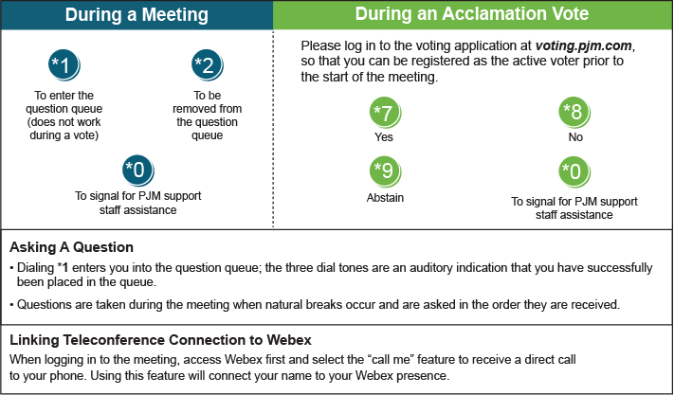

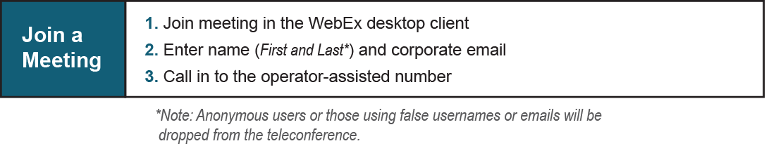
Provide feedback on the progress of this group: Facilitator Feedback Form
Visit learn.pjm.com, an easy-to-understand resource about the power industry and PJM’s role.

