Markets & Reliability Committee
Webex Only
January 26, 2022
9:00 a.m. – 12:30 p.m. EPT
*Operator assisted phone lines will be opened 30 minutes prior to the start of the meeting. Due to the high volume of remote participation, stakeholders are asked to connect early to allow additional time for operator queue processing.

Administration (9:00-9:15)
Welcome, announcements and Anti-trust, Code of Conduct, and Public Meetings/Media Participation – Stu Bresler and Dave Anders
Amanda Egan will provide an update on the need for voting members to update their browser’s transport layer security (TLS) version due to weak encryption and its impact to the Voting Application.

Consent Agenda (9:15-9:20)
- Approve minutes of the December 15, 2021 meeting of the Markets and Reliability Committee (MRC).
- Endorse proposed revisions to Manual 38: Operations Planning resulting from its periodic review.

Endorsements (9:20-10:20)
- Enhancements to Dead Bus Replacement Logic (9:20-9:35)
Vijay Shah will review conforming revisions to Manual 11: Energy and Ancillary Services Market Operations addressing enhancements to the Dead Bus Replacement logic for assigning prices to de-energized pricing nodes. The committee will be asked to endorse the proposed revisions to Manual 11: Energy and Ancillary Services Market Operations.
- Fuel Cost Policy Standards and Schedule 2 Penalties (9:35-9:50)
Melissa Pilong will review the PJM/IMM Package elaborating upon and addressing clarifications to Fuel Cost Policy standards and Schedule 2 Penalty revisions. The committee will be asked to endorse the proposed solution and corresponding revisions to Manual 15: Cost Development Guidelines and the Operating Agreement (OA).
- Regulation for Virtual Combined Cycles (9:50-10:10)
Michael Olaleye will review the proposed solution addressing Regulation for Virtual Combined Cycles. The committee will be asked to endorse the proposed solution and corresponding revisions to M-12: Balancing Operations.
Issue Tracking: Regulation for Virtual Combined Cycles

- Resource Adequacy Senior Task Force (RASTF) Issue Charge (10:10-11:00)
- Alex Scheirer and Pat Bruno will review a proposed Issue Charge as endorsed by the RASTF.
- Bruce Campbell, C Power, and Brian Kauffman, Enel X North America, will discuss perspectives regarding DR as a supply resource.
- Steve Lieberman, AMP, will discuss a proposed alternative RASTF Issue Charge.
The committee will be asked to approve a proposed Issue Charge.
- Max Emergency Correction for Gas CTs (11:00-11:25)
Chris Pilong will review proposed revisions to Manual 13: Emergency Operations addressing a temporary change to Max Emergency for gas combustion turbines. The committee will be asked to approve the issue charge and solution as part of the Quick Fix process outlined in Section 8.6.1 of Manual 34. Endorsement will be sought upon first read.

First Readings (11:25-11:45)
- Manuals (11:25-11:45)
  - Rebecca Stadelmeyer will review proposed conforming revisions to Manual 27: Open Access Transmission Tariff Accounting resulting from PJM’s recent formula rate filing (Docket No. ER22- 26). The committee will be asked to endorse the proposed revisions at its next meeting.
  - Benjamin Miller will review proposed revisions to Manual 40: Training and Certification Requirements resulting from its periodic review. The committee will be asked to endorse the proposed revisions at its next meeting.

Informational Reports (11:45-12:30)
- Addressing Defaulting Member’s Financial Transmission Rights (11:45-12:30)
Nigeria Bloczynski & Chris O’Hara will provide an update regarding the Hill Energy default and will seek member input on options for addressing the defaulted FTR portfolio

Future Agenda Items (12:30)

Future Meeting Dates and Materials |  |  |  | Materials Due  to Secretary | Materials Published
Date | Time | Location
February 24, 2022 | 9:00 a.m. |  | Webex | February 14, 2022 | February 17, 2022
March 23, 2022 | 9:00 a.m. |  | Webex | March 11, 2022 | March 16, 2022
April 27, 2022 | 9:00 a.m. |  | Webex | April 15, 2022 | April 20, 2022
May 25, 2022 | 9:00 a.m. |  | PJM Conference & Training Center | May 13, 2022 | May 18, 2022
June 29, 2022 | 9:00 a.m. |  | PJM Conference & Training Center | June 17, 2022 | June 22, 2022

Author: M. Greening

Antitrust:
You may not discuss any topics that violate, or that might appear to violate, the antitrust laws including but not limited to agreements between or among competitors regarding prices, bid and offer practices, availability of service, product design, terms of sale, division of markets, allocation of customers or any other activity that might unreasonably restrain competition. If any of these items are discussed the chair will re-direct the conversation. If the conversation still persists, parties will be asked to leave the meeting or the meeting will be adjourned.

Code of Conduct:
As a mandatory condition of attendance at today's meeting, attendees agree to adhere to the PJM Code of Conduct as detailed in PJM Manual M-34 section 4.5, including, but not limited to, participants' responsibilities and rules regarding the dissemination of meeting discussion and materials.

Public Meetings/Media Participation:
Unless otherwise noted, PJM stakeholder meetings are open to the public and to members of the media. Members of the media are asked to announce their attendance at all PJM stakeholder meetings at the beginning of the meeting or at the point they join a meeting already in progress. Members of the Media are reminded that speakers at PJM meetings cannot be quoted without explicit permission from the speaker. PJM Members are reminded that "detailed transcriptional meeting notes" and white board notes from "brainstorming sessions" shall not be disseminated. Stakeholders are also not allowed to create audio, video or online recordings of PJM meetings. PJM may create audio, video or online recordings of stakeholder meetings for internal and training purposes, and your participation at such meetings indicates your consent to the same.
Participant Identification in Webex:
When logging into the Webex desktop client, please enter your real first and last name as well as a valid email address. Be sure to select the “call me” option.
PJM support staff continuously monitors Webex connections during stakeholder meetings. Anonymous users or those using false usernames or emails will be dropped from the teleconference.

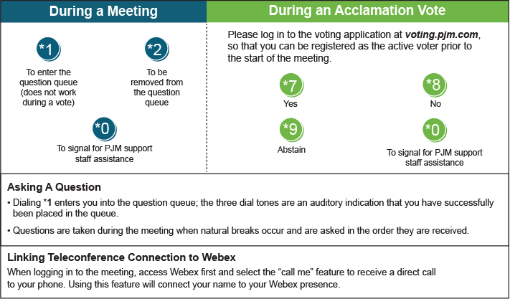

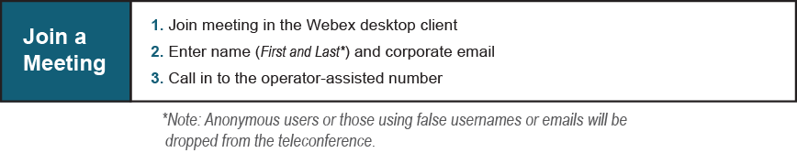
Provide feedback on the progress of this group: Facilitator Feedback Form
Visit learn.pjm.com, an easy-to-understand resource about the power industry and PJM’s role.

