Markets & Reliability Committee
PJM Conference and Training Center / WebEx
June 29, 2022
9:00 a.m. – 12:25 p.m. EPT
*Operator assisted phone lines will be opened 30 minutes prior to the start of the meeting. Due to the high volume of remote participation, stakeholders are asked to connect early to allow additional time for operator queue processing.

Administration (9:00-9:05)
Welcome, announcements and Anti-trust, Code of Conduct, and Public Meetings/Media Participation – Stu Bresler and Michele Greening

Consent Agenda (9:05-9:10)
- Approve minutes of the May 25, 2022 meeting of the Markets and Reliability Committee (MRC).
- Endorse proposed revisions to Manual 29: Billing resulting from its periodic review.

Endorsements (9:10-9:40)
- Service on PJM for Rate and Waiver Filings under Governing Agreements (9:10-9:30)
Steve Pincus will review a proposed Problem Statement and Issue Charge addressing service to PJM of Members’ Tariff rate and waiver filings under PJM Governing Agreements. The committee will be asked to approve the Issue Charge.
- Operating Committee Charter (9:30-9:40)
Paul McGlynn will present proposed revisions to the Operating Committee Charter. The committee will be asked to approve the revised Charter.

First Readings (9:40-10:55)
- Application of Designated Entity Agreement (9:40-10:05)
Denise Foster, EKPC on behalf of joint TO sponsors, and Greg Poulos, CAPS on behalf of the Delaware Division of the Public Advocate and the New Jersey Division of the Rate Counsel, will review proposed Issue Charges seeking to address the terms & conditions and the application of Designated Entity Agreement. The committee will be asked to approve a proposed Issue Charge at its next meeting.
Issue Tracking: Application of Designated Entity Agreement
- Market Seller Offer Cap (10:05-10:30)
Dave Anders and Pat Bruno will review proposed revisions to the Market Seller Offer Cap (MSOC) as endorsed by the Resource Adequacy Senior Task Force (RASTF). The committee will be asked to endorse the proposed Tariff revisions at its next meeting.
Issue Tracking: Capacity Market Reform
- Manuals (10:30-10:55)
  - Jack O’Neill will review conforming changes to Manual 01: Control Center and Data Exchange Requirements, Manual 18: PJM Capacity Market, and Manual 28: Operating Agreement Accounting to support the implementation of new testing requirements which were approved in Docket No. ER19-1590 and will become effective with the 2023/2023 Delivery Year. The committee will be asked to endorse the proposed revisions at its next meeting.
Issue Tracking: Load Management Testing Requirements
  - Dave Egan will review proposed revisions to Manual 14D: Generator Operational Requirements to support the process timing changes for generation deactivations. The committee will be asked to endorse the proposed revisions at its next meeting.
Issue Tracking: Deactivation Analysis Period
  - Tom Hauske will review proposed revisions to Manual 28: Operating Agreement Accounting to support the Startup Cost Offer Development proposal the committee endorsed at the April 2022 meeting. The committee will be asked to endorse the proposed revisions at its next meeting.
Issue Tracking: Start-Up Cost Offer Development

Informational Report (10:55-12:25)
- Load Shed and Performance Assessment Interval (PAI) Event Update (10:55-11:40)
Paul McGlynn, Becky Carroll, and Phil D’Antonio will provide an informational update regarding the recent load shed and PAI events that occurred in June.
- Base Residual Auction (BRA) Auction Results (11:40-12:05)
Pete Langbein will provide a review of the 2023/2024 Base Residual Auction (BRA) results posted on June 21, 2022.
- Informational Update on NOPRs (12:05-12:25)
Ken Seiler will provide an update on the three recent NOPRs issued regarding planning and operational topics.
- RM22-14-000, Notice of Proposed Rule Making (“NOPR”), Improvements to Generator Interconnection Procedures and Agreements ( “Interconnection NOPR”)
- RM22-10-000 Notice of Proposed Rulemaking on Transmission System Planning Performance Requirements for Extreme Weather (“NOPR on Planning Performance for Extreme Weather”).
- RM22-16-000, Notice of Proposed Rulemaking to propose to direct Transmission Providers to submit one-time informational reports on extreme weather vulnerability assessments, climate change, extreme weather and electric system reliability (“One-Time Information Report NOPR”).

Informational Posting Only
- PJM Manual 03 Attachment E Automatic Sectionalizing Schemes
The PJM Manual 03 Attachment E Automatic Sectionalizing Schemes Pending Approval and Recent Changes document has been posted as an Information Only item to the June MRC meeting materials.

Future Agenda Items (12:25)

Future Meeting Dates and Materials |  |  |  | Materials Due  to Secretary | Materials Published
Date | Time | Location
July 27, 2022 | 9:00 a.m. |  | PJM Conference & Training Center and WebEx | July 15, 2022 | July 20, 2022
August 24, 2022 | 9:00 a.m. |  | PJM Conference & Training Center and WebEx | August 12, 2022 | August 17, 2022
September 21, 2022 | 9:00 a.m. |  | PJM Conference & Training Center and WebEx | September 9, 2022 | September 14, 2022
October 24, 2022 | 1:00 p.m. |  | Hyatt Regency Chesapeake Bay Golf Resort, Spa and Marina in Cambridge, MD | October 12, 2022 | October 17, 2022
November 16, 2022 | 9:00 a.m. |  | PJM Conference & Training Center and WebEx | November 4, 2022 | November 9, 2022
December 21, 2022 | 9:00 a.m. |  | PJM Conference & Training Center and WebEx | December 9, 2022 | December 14, 2022

Author: M. Greening

Antitrust:
You may not discuss any topics that violate, or that might appear to violate, the antitrust laws including but not limited to agreements between or among competitors regarding prices, bid and offer practices, availability of service, product design, terms of sale, division of markets, allocation of customers or any other activity that might unreasonably restrain competition. If any of these items are discussed the chair will re-direct the conversation. If the conversation still persists, parties will be asked to leave the meeting or the meeting will be adjourned.

Code of Conduct:
As a mandatory condition of attendance at today's meeting, attendees agree to adhere to the PJM Code of Conduct as detailed in PJM Manual M-34 section 4.5, including, but not limited to, participants' responsibilities and rules regarding the dissemination of meeting discussion and materials.

Public Meetings/Media Participation:
Unless otherwise noted, PJM stakeholder meetings are open to the public and to members of the media. Members of the media are asked to announce their attendance at all PJM stakeholder meetings at the beginning of the meeting or at the point they join a meeting already in progress. Members of the Media are reminded that speakers at PJM meetings cannot be quoted without explicit permission from the speaker. PJM Members are reminded that "detailed transcriptional meeting notes" and white board notes from "brainstorming sessions" shall not be disseminated. Stakeholders are also not allowed to create audio, video or online recordings of PJM meetings. PJM may create audio, video or online recordings of stakeholder meetings for internal and training purposes, and your participation at such meetings indicates your consent to the same.
Participant Identification in Webex:
When logging into the Webex desktop client, please enter your real first and last name as well as a valid email address. Be sure to select the “call me” option.
PJM support staff continuously monitors Webex connections during stakeholder meetings. Anonymous users or those using false usernames or emails will be dropped from the teleconference.

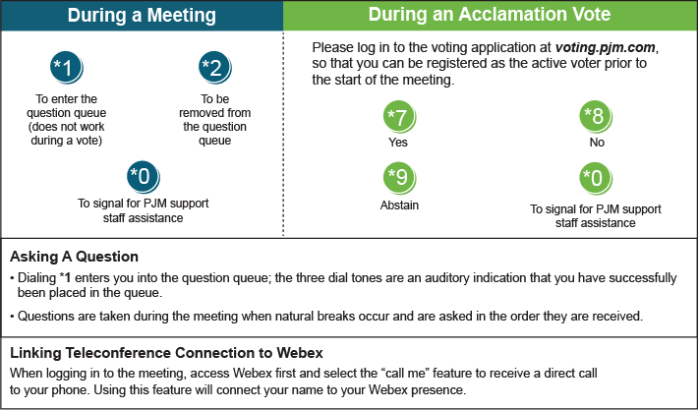

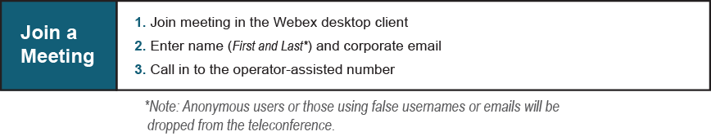
Provide feedback on the progress of this group: Facilitator Feedback Form
Visit learn.pjm.com, an easy-to-understand resource about the power industry and PJM’s role.

