Operating Committee
PJM Conference and Training Center
May 14, 2020
9:00 a.m. – 12:00 p.m. EPT

Administration (9:00-9:15)
Danielle Croop, PJM, will provide announcements; review the Antitrust, Code of Conduct, Public Meetings/Media Participation, and the WebEx Participant Identification Requirement.
  - Review and approve the Operating Committee (OC) agenda for this meeting.
  - Review and approve draft minutes of the April 16 OC meeting.
  - Review of the OC work plan.

Review of Operations (9:15 - 9:45)
PJM COVID-19 Update
Paul McGlynn, PJM, will provide an update on PJM’s operations plan in response to COVID-19. https://pjm.com/committees-and-groups/pandemic-coordination.aspx

Review of Operating Metrics
Stephanie Monzon, PJM, will review the April 2020 PJM operating metrics slides. Metrics will include PJM’s load forecast error, BAAL performance, transmission / generation outage statistics, and Perfect Dispatch historical performance.

Endorsements/Approvals (9:45 – 11:00)
Manuals
  - Manual 01 Changes
Bilge Derin, PJM, will review the proposed changes to PJM Manual 01: Control Center and Data Exchange.
The Operating Committee will be asked to endorse these changes

b. Manual 03 CEII Changes
Lagy Mathew, PJM, will review the proposed changes to Manual 03: Transmission Operations and a proposed Manual 03B.
The Operating Committee will be asked to endorse these changes

c. Manual 03 Changes
Lagy Mathew, PJM, will review the proposed changes to PJM Manual 03: Transmission Operations.
The Operating Committee will be asked to endorse these changes

d. Manual 36 Changes
Liem Hoang, PJM, will review the proposed changes to PJM Manual 36: System Restoration
The Operating Committee will be asked to endorse these changes

5. Black Start Problem Statement and Issue Charge
David Kimmel, PJM, will review a problem statement and issue charge around the substitution and termination of black start resources.
The Operating Committee will be asked to endorse the Issue Charge

- Proposed Amendment to Blackstart PS/IC
Joe Bowring, IMM, will present a proposed amendment to the PS/IC to include Minimum Tank Suction Level as a key work activity in the Black Start Issue Charge.
This item is contingent upon endorsement of the Black Start Issue Charge in Item 5

- Black Start Testing, Termination Rules, Substitution, and CRF Education
Becky Davis, PJM, will provide education on black start testing, termination rules, substitution, and CRF.
This item is contingent upon endorsement of the Black Start Issue Charge in Item 5

Tool and Informational Updates (11:00 – 11:30)
6. Regulation Performance Update
Gabrielle Genuario, PJM, will provide an update on PJM regulation market performance.

7. NERC Lessons Learned
Donnie Bielak with review the latest posted NERC Lessons Learned reports.

8. Reliability Compliance Update
Srinivas Kappagantula, PJM, will provide an update on NERC, SERC and RFC standards, and other pertinent regulatory and compliance information, and solicit feedback from the members on Reliability Compliance efforts.

OC Subcommittee/ Task Force Informational Section
System Operations Subcommittee (SOS): SOS Website

Data Management Subcommittee (DMS): DMS Website

Distributed Energy Resources Subcommittee (DERS): DERS Website

System Restoration Coordinators Subcommittee (SRCS): SRCS Website

Primary Frequency Response Sr. Task Force (PFRSTF): PFRSTF Website

Fuel Requirements for Black Start Resources: Fuel Requirements for Black Start Resources Issue Tracker

Future Meeting Dates
June 4, 2020 | 9:00 a.m. | PJM Conference & Training Center/ WebEx
July 9, 2020 | 9:00 a.m. | PJM Conference & Training Center/ WebEx
August 6, 2020 | 9:00 a.m. | PJM Conference & Training Center/ WebEx
September 3, 2020 | 9:00 a.m. | PJM Conference & Training Center/ WebEx
October 8, 2020 | 9:00 a.m. | PJM Conference & Training Center/ WebEx
November 6, 2020 | 9:00 a.m. | PJM Conference & Training Center/ WebEx
December 3, 2020 | 9:00 a.m. | PJM Conference & Training Center/ WebEx

Author: L. Strella Wahba

Antitrust:
You may not discuss any topics that violate, or that might appear to violate, the antitrust laws including but not limited to agreements between or among competitors regarding prices, bid and offer practices, availability of service, product design, terms of sale, division of markets, allocation of customers or any other activity that might unreasonably restrain competition. If any of these items are discussed the chair will re-direct the conversation. If the conversation still persists, parties will be asked to leave the meeting or the meeting will be adjourned.

Code of Conduct:
As a mandatory condition of attendance at today's meeting, attendees agree to adhere to the PJM Code of Conduct as detailed in PJM Manual M-34 section 4.5, including, but not limited to, participants' responsibilities and rules regarding the dissemination of meeting discussion and materials.

Public Meetings/Media Participation:
Unless otherwise noted, PJM stakeholder meetings are open to the public and to members of the media. Members of the media are asked to announce their attendance at all PJM stakeholder meetings at the beginning of the meeting or at the point they join a meeting already in progress. Members of the Media are reminded that speakers at PJM meetings cannot be quoted without explicit permission from the speaker. PJM Members are reminded that "detailed transcriptional meeting notes" and white board notes from "brainstorming sessions" shall not be disseminated. Stakeholders are also not allowed to create audio, video or online recordings of PJM meetings. PJM may create audio, video or online recordings of stakeholder meetings for internal and training purposes, and your participation at such meetings indicates your consent to the same.
Participant Identification in WebEx:
When logging into the WebEx desktop client, please enter your real first and last name as well as a valid email address. Be sure to select the “call me” option.
PJM support staff continuously monitors WebEx connections during stakeholder meetings. Anonymous users or those using false usernames or emails will be dropped from the teleconference.



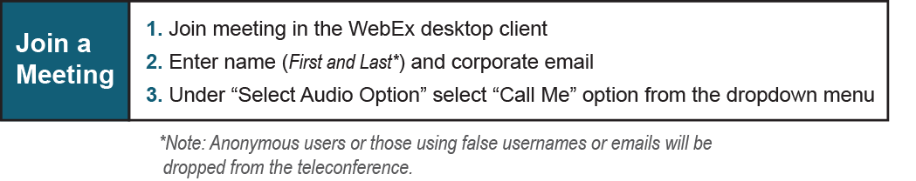
Provide feedback on the progress of this group: Facilitator Feedback Form
Visit learn.pjm.com, an easy-to-understand resource about the power industry and PJM’s role.

