Operating Committee
WebEx Only
January 13, 2021
9:00 a.m. – 2:00 p.m. EST

Administration (9:00-9:15)
Lauren Strella Wahba, PJM, will provide announcements; review the Antitrust, Code of Conduct, Public Meetings/Media Participation, and the WebEx Participant Identification Requirement.
  - Review and approve draft minutes from the December 2nd OC meeting.

  - Review of the OC work plan.

  - Weak Encryption Retirement
Amanda Egan will provide an update on the retirement of Weak Encryption and its impact to the
Voting Application.

Review of Operations (9:15-9:30)
PJM COVID-19 Update
Paul McGlynn, PJM, will provide an update on PJM’s operations plan in response to COVID-19. https://pjm.com/committees-and-groups/pandemic-coordination.aspx

Review of Operating Metrics
Stephanie Monzon, PJM, will review the December 2021 PJM operating metrics slides. Metrics will include PJM’s load forecast error, BAAL performance, and transmission / generation outage statistics.

Endorsements/Approvals (9:30-10:00)
- Manual 38: Operations Planning
Liem Hoang, PJM, will review Manual 38 changes as a part of the periodic review.
The Operating Committee will be asked to endorse these changes at today’s meeting.

- Renewable Dispatch Issue Charge and Problem Statement
Darrell Frogg, PJM, will review an Issue Charge and Problem Statement that will address the improvement of the dispatching process of renewable resources and increase forward-looking visibility.
The Operating Committee will be asked to approve the Issue Charge at today’s meeting.

First Reading (10:00-10:30)
- Manual 40: Training and Certification Requirements
Benjamin Miller, PJM, will review Manual 40 changes as a part of the periodic review.
The Operating Committee will be asked to endorse these changes at its next meeting.

- TO/TOP Matrix Review
Gizella Mali, PJM, will review Version 16 of the TO/TOP Matrix.
The Operating Committee will be asked to recommend the TOA-AC approve the TO/TOP Matrix at its next meeting.

Additional Items (10:30-11:30)
- Dynamic Rating Issue
Chris Callaghan, PJM, and Mark Stanisz, PJM, will provide an informational update on PJM’s plan for the preparation of its compliance filing in Docket No. RM20-16-000 relating to Managing Transmission Line Ratings; and its plan to bring the related Dynamic Rating Problem Statement and Issue Charge back for a second first read at the February OC.

- Informational Update: Review of M14D Changes to Deactivation Timing
Dave Egan, PJM, will provide an informational update on the Quick Fix initiative to make changes to Manual 14D: Generator Operational Requirements regarding Deactivation Timing that is currently being worked through the Planning Committee.
- Update on Illinois Clean Energy Jobs Act
Chris Pilong, PJM, will provide an update on the Illinois EPA legislation and PJMs response.
- System Operations Subcommittee (SOS) Report
Donnie Bielak, PJM, will provide a summary of the most recent SOS meeting.

- Unit Specific Parameters 2022/2023 DY Update
Tom Hauske, PJM, will provide an update on Unit Specific Parameters for the 2022/2023 DY.

- Reliability Compliance Update
Becky Davis, PJM, will provide an update on NERC, SERC, RF, and NAESB standards, and other pertinent regulatory and compliance information, and solicit feedback from the members on Reliability Compliance efforts.

LUNCH (11:30 – 12:00)

Working Items (12:00-2:00)
- Reliability Products and Services Assessment
Chris Pilong, PJM, will lead a discussion to evaluate the essential reliability services and determine which services should be sent to the RASTF for potential inclusion as a capacity product attribute. Additionally, the Operating Committee will be asked to evaluate the remaining reliability services to identify any gaps that may need to be addressed in other Stakeholder venues.

- IROL-CIP Cost Recovery
Darrell Frogg, PJM, will provide a brief overview of the Issue Charge and Problem Statement followed by education.

Informational Only Postings

OC Subcommittee/ Task Force Informational Section
System Operations Subcommittee (SOS): SOS Website
Data Management Subcommittee (DMS): DMS Website
DER & Inverter-Based Resources Subcommittee (DIRS): DIRS Website
Fuel Requirements for Black Start Resources: Fuel Reqt. for Black Start Resources Issue Tracker
Synchronous Reserve Deployment Task Force: SRDTF Website
IROL – CIP Cost Recovery: IROL – CIP Cost Recovery Issue Tracker

Future Meeting Dates and Materials |  |  | Materials Due  to Secretary | Materials Published
Date | Time | Location | 5 p.m. | 4 p.m.
February 10, 2022 | 9 a.m. | WebEx | January 31, 2022 | February 3, 2022
March 10, 2022 | 9 a.m. | WebEx | February 28, 2022 | March 3, 2022
April 14, 2022 | 9 a.m. | WebEx | April 4, 2022 | April 7, 2022
May 12, 2022 | 9 a.m. | WebEx | May 2, 2022 | May 5, 2022
June 9, 2022 | 9 a.m. | WebEx | May 30, 2022 | June 2, 2022

Author: L. Strella Wahba

Antitrust:
You may not discuss any topics that violate, or that might appear to violate, the antitrust laws including but not limited to agreements between or among competitors regarding prices, bid and offer practices, availability of service, product design, terms of sale, division of markets, allocation of customers or any other activity that might unreasonably restrain competition. If any of these items are discussed the chair will re-direct the conversation. If the conversation still persists, parties will be asked to leave the meeting or the meeting will be adjourned.

Code of Conduct:
As a mandatory condition of attendance at today's meeting, attendees agree to adhere to the PJM Code of Conduct as detailed in PJM Manual M-34 section 4.5, including, but not limited to, participants' responsibilities and rules regarding the dissemination of meeting discussion and materials.

Public Meetings/Media Participation:
Unless otherwise noted, PJM stakeholder meetings are open to the public and to members of the media. Members of the media are asked to announce their attendance at all PJM stakeholder meetings at the beginning of the meeting or at the point they join a meeting already in progress. Members of the Media are reminded that speakers at PJM meetings cannot be quoted without explicit permission from the speaker. PJM Members are reminded that "detailed transcriptional meeting notes" and white board notes from "brainstorming sessions" shall not be disseminated. Stakeholders are also not allowed to create audio, video or online recordings of PJM meetings. PJM may create audio, video or online recordings of stakeholder meetings for internal and training purposes, and your participation at such meetings indicates your consent to the same.
Participant Identification in WebEx:
When logging into the WebEx desktop client, please enter your real first and last name as well as a valid email address. Be sure to select the “call me” option.
PJM support staff continuously monitors WebEx connections during stakeholder meetings. Anonymous users or those using false usernames or emails will be dropped from the teleconference.

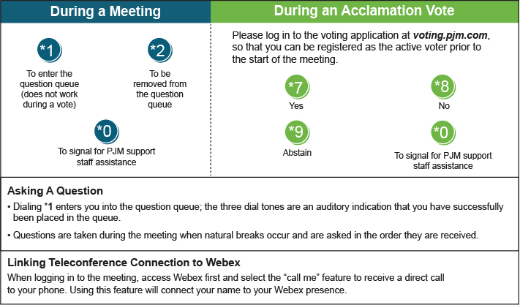

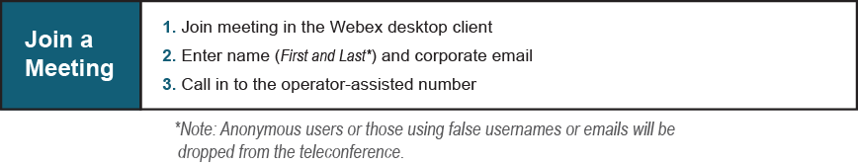
Provide feedback on the progress of this group: Facilitator Feedback Form
Visit learn.pjm.com, an easy-to-understand resource about the power industry and PJM’s role.

