Operating Committee
PJM Conference & Training Center, Audubon, PA
July 14, 2022
9:00 a.m. – 3:00 p.m. EDT

*Operator assisted phone lines will be opened 30 minutes prior to the start of the meeting. Due to the high volume of remote participation, stakeholders are asked to connect early to allow additional time for operator queue processing.

Administration (9:00-9:15)
Jeff McLaughlin, PJM, will provide announcements; review the Antitrust, Code of Conduct, Public Meetings/Media Participation, and the WebEx Participant Identification Requirement.
  - Review and approve draft minutes from the June 9 OC meeting.

  - Review of the OC work plan.

Review of Operations (9:15 - 10:45)
- PJM COVID-19 Update
Paul McGlynn, PJM, will review an update on PJM’s operations plan in response to COVID-19.
https://pjm.com/committees-and-groups/pandemic-coordination.aspx

Review of AEP Load Shed Events
Donnie Bielak, PJM, will review the AEP load shed events and related operational impacts that occurred during the week of June 13.

Review of Operating Metrics
Stephanie Schwarz, PJM, will review the June 2022 PJM operating metrics slides. Metrics will include PJM’s load forecast error, BAAL performance, and transmission / generation outage statistics.

- Security Update
Steve McElwee, PJM, will provide a security briefing.

Endorsements/Approvals (10:45 – 11:05)
- Internal NITS Process
Susan McGill, PJM, will review a proposed Issue Charge and Problem Statement that will clarify and enhance the processes related to internal Network Integration Transmission Service (NITS).
The Operating Committee will be asked to approve the Issue Charge at today’s meeting.

- Manual 14D: Generator Operational Requirements
Dave Egan, PJM, will review changes to Manual 14D: Generator Operational Requirements as a part of the Deactivation Analysis Period quick fix process. During a review of these quick fix revisions, stakeholders raised a concern over the transparency of the Reliability Must Run (RMR) process. As a result, an informational slide deck has been posted under this agenda item to provide detail and clarity to the RMR process.
The Operating Committee will be asked to endorse these changes at today’s meeting.
Deactivation Analysis Period

First Reading (11:05 – 12:20)
- Max Emergency Changes for Resource Limitation Reporting
As a result of changes made to the proposed solution packages, as well as the additional education being provided under part (a) below, another first read of solution packages will be performed.
- Seth Schwartz, Energy Ventures Analysis, will provide education via a presentation of ‘US Coal Markets and the Current Coal Supply Shortage’. This education is sponsored by EKPC, who will perform a brief introduction.
- Chris Pilong, PJM, will review Package A addressing the Max Emergency Changes for Resource Limitation Reporting matrix as part of the Consensus Based Issue Resolution Lite process.
- A representative from Monitoring Analytics will review Package B addressing the Max Emergency Changes for Resource Limitation Reporting matrix as part of the Consensus Based Issue Resolution Lite process.
The Operating Committee will be asked to endorse these proposals at its next meeting.
Issue Tracking: Max Emergency Changes for Resource Limitation Reporting

- Manual 14D: Generator Operational Requirements and Manual 10: Pre-Scheduling Operations
Andrew Levitt, PJM, will review conforming changes to Manual 14D and Manual 10 as part of the phase one hybrid resources issue.
The Operating Committee will be asked to endorse these changes at its next meeting.
Solar-Battery Hybrid Resources Issue Tracking

Additional Items (12:20 – 1:15)
Lunch (12:20 – 12:50)
- PPL Dynamic Line Rating Implementation Update
Dave Hislop, PJM, will provide an update on the implementation of the PPL Dynamic Line Rating.

- Review of recent FERC NOPR
Simon Tam, PJM, will summarize the recently issued FERC Notice of Public Rulemaking (Docket Nos. RM22-16-000 / AD21-13-000) directing RTOs/ISOs to file a one-time informational report on policy/processes for performing extreme weather vulnerability assessments.

Working Items (1:15 - 3:00)
- Internal NITS Process
Pending OC approval of the Internal NITS Process Issue Charge (Item 5 on today’s OC agenda), Susan McGill, Jeff McLaughlin and Julia Spatafore, PJM, will provide education on various aspects of internal NITS processes as part of the CBIR Lite process. A CBIR matrix containing a preliminary set of interests and design components has also be posted for informational purposes.

- Renewable Dispatch
Paul McGlynn, PJM, will facilitate a discussion to identify solution options and review solution packages on the Renewable Dispatch matrix as part of the Consensus Based Issue Resolution process.
Issue Tracking: Renewable Dispatch

Informational Only Postings
- System Operations Subcommittee (SOS)
Donnie Bielak, PJM, will provide a summary of the most recent SOS meeting.

- Administrative Update to Manual 03: Transmission Operations
A list of pending approval & recent changes to "Manual 03: Transmission Operations, Attachment E: Automatic Sectionalizing Schemes" has been provided in the posted meeting materials. This list has also been posted on OASIS under System Information. Dean Manno, PJM, will be available to address any stakeholder questions.

- Reliability Compliance Update
Becky Davis, PJM, will provide an update on NERC, SERC, RF, and NAESB standards, and other pertinent regulatory and compliance information, and solicit feedback from the members on Reliability Compliance efforts.

- Managing Transmission Line Ratings Order No. 881 Compliance Filing (RM20-16-000) Update
On July 12, 2022 PJM will make its Order No. 881 compliance filing related to ambient adjusted ratings. SMEs will be available should stakeholders have any questions related to the filing.
Order 881

OC Subcommittee/ Task Force Informational Section
System Operations Subcommittee (SOS): SOS Website
Data Management Subcommittee (DMS): DMS Website
DER & Inverter-Based Resources Subcommittee (DIRS): DIRS Website
Fuel Requirements for Black Start Resources: Fuel Reqt. for Black Start Resources Issue Tracker
Synchronous Reserve Deployment Task Force: SRDTF Website
IROL – CIP Cost Recovery: IROL – CIP Cost Recovery Issue Tracker

Future Meeting Dates and Materials |  |  | Materials Due  to Secretary | Materials Published
Date | Time | Location | 5 p.m. | 4 p.m.
August 11, 2022 | 9 a.m. | PJM Conference & Training Center and WebEx | August 1, 2022 | August 4, 2022
September 8, 2022 | 9 a.m. | PJM Conference & Training Center and WebEx | August 29, 2022 | September 1, 2022
October 7, 2022 | 9 a.m. | PJM Conference & Training Center and WebEx | September 27, 2022 | September 30, 2022
November 3, 2022 | 9 a.m. | PJM Conference & Training Center and WebEx | October 24, 2022 | October 27, 2022
December 8, 2022 | 9 a.m. | PJM Conference & Training Center and WebEx | November 28, 2022 | December 1, 2022

Author: Jeffrey McLaughlin

Antitrust:
You may not discuss any topics that violate, or that might appear to violate, the antitrust laws including but not limited to agreements between or among competitors regarding prices, bid and offer practices, availability of service, product design, terms of sale, division of markets, allocation of customers or any other activity that might unreasonably restrain competition. If any of these items are discussed the chair will re-direct the conversation. If the conversation still persists, parties will be asked to leave the meeting or the meeting will be adjourned.

Code of Conduct:
As a mandatory condition of attendance at today's meeting, attendees agree to adhere to the PJM Code of Conduct as detailed in PJM Manual M-34 section 4.5, including, but not limited to, participants' responsibilities and rules regarding the dissemination of meeting discussion and materials.
Public Meetings/Media Participation:
Unless otherwise noted, PJM stakeholder meetings are open to the public and to members of the media. Members of the media are asked to announce their attendance at all PJM stakeholder meetings at the beginning of the meeting or at the point they join a meeting already in progress. Members of the Media are reminded that speakers at PJM meetings cannot be quoted without explicit permission from the speaker. PJM Members are reminded that "detailed transcriptional meeting notes" and white board notes from "brainstorming sessions" shall not be disseminated. Stakeholders are also not allowed to create audio, video or online recordings of PJM meetings. PJM may create audio, video or online recordings of stakeholder meetings for internal and training purposes, and your participation at such meetings indicates your consent to the same.
Participant Identification in WebEx:
When logging into the WebEx desktop client, please enter your real first and last name as well as a valid email address. Be sure to select the “call me” option.
PJM support staff continuously monitors WebEx connections during stakeholder meetings. Anonymous users or those using false usernames or emails will be dropped from the teleconference.

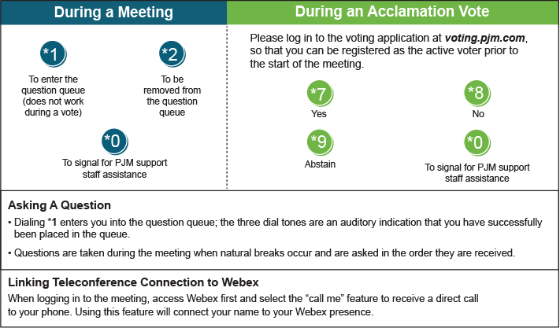

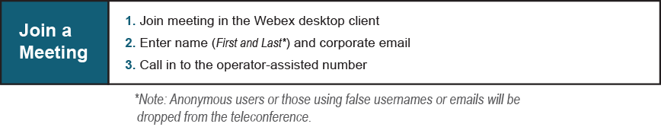

Provide feedback on the progress of this group: Facilitator Feedback Form
Visit learn.pjm.com, an easy-to-understand resource about the power industry and PJM’s role.

