PC Special Session: Merchant Transmission and Offshore Wind
PJM Conference and Training Center
April 16, 2019
1:00 p.m. – 4:00 p.m. EPT

Administration (1:00-1:15)
Welcome, review agenda, PJM meeting guidelines, roll call and Anti-trust and Code of Conduct announcements – Mr. John Reynolds and Ms. Natalie Tacka

Work Plan Discussion (1:15-1:30)
Problem Statement / Issue Charge Overview (1:15-1:25)
Mr. John Reynolds and Ms. Suzanne Glatz, PJM, will lead a review of the Problem Statement and Issue Charge approved by the Planning Committee at its February 7, 2019 meeting.
Work Plan (1:25-1:30)
Mr. Reynolds will lead a discussion of the work plan and meeting schedule.

Education (1:30-3:30)
- Education on New Service Requests in PJM
Ms. Anupama Janapareddy and Ms. Lisa Krizenoskas, PJM, will provide education on the current interconnection study process and the interconnection rights that can be granted through the process. This is intended to establish a baseline for future discussion and clarify what is unique about proposed merchant transmission developer requests related to offshore wind development.

Consensus Based Issue Resolution (CBIR) (3:30-3:45)
Interest Identification
Mr. Reynolds will lead a discussion around interest identification for Phase 1 of the Merchant Transmission and Offshore Wind special session.

Wrap-up: Action Items, Future Agenda Items, Reminders (3:45-4:00)
Mr. Reynolds and Ms. Tacka will close the meeting by reviewing action items and previewing topics for the next meeting.

Future Meeting Dates
May 3, 2019 | 1:00 p.m. | PJM Conference & Training Center/ WebEx
May 31, 2019 | 1:00 p.m. | PJM Conference & Training Center/ WebEx
June 28, 2019 | 1:00 p.m. | PJM Conference & Training Center/ WebEx
July 24, 2019 | 1:00 p.m. | PJM Conference & Training Center/ WebEx
Author: Natalie Tacka

Antitrust:
You may not discuss any topics that violate, or that might appear to violate, the antitrust laws including but not limited to agreements between or among competitors regarding prices, bid and offer practices, availability of service, product design, terms of sale, division of markets, allocation of customers or any other activity that might unreasonably restrain competition. If any of these items are discussed the chair will re-direct the conversation. If the conversation still persists, parties will be asked to leave the meeting or the meeting will be adjourned.

Code of Conduct:
As a mandatory condition of attendance at today's meeting, attendees agree to adhere to the PJM Code of Conduct as detailed in PJM Manual M-34 section 4.5, including, but not limited to, participants' responsibilities and rules regarding the dissemination of meeting discussion and materials.

Public Meetings/Media Participation:
Unless otherwise noted, PJM stakeholder meetings are open to the public and to members of the media. Members of the media are asked to announce their attendance at all PJM stakeholder meetings at the beginning of the meeting or at the point they join a meeting already in progress. Members of the Media are reminded that speakers at PJM meetings cannot be quoted without explicit permission from the speaker. PJM Members are reminded that "detailed transcriptional meeting notes" and white board notes from "brainstorming sessions" shall not be disseminated. Stakeholders are also not allowed to create audio, video or online recordings of PJM meetings. PJM may create audio, video or online recordings of stakeholder meetings for internal and training purposes, and your participation at such meetings indicates your consent to the same.
Participant Identification in WebEx:
When logging into the WebEx desktop client, please enter your real first and last name as well as a valid email address. Be sure to select the “call me” option.
PJM support staff continuously monitors WebEx connections during stakeholder meetings. Anonymous users or those using false usernames or emails will be dropped from the teleconference.

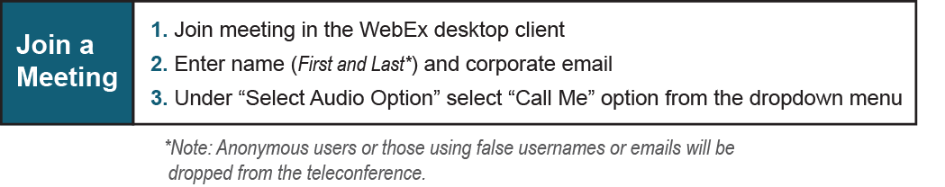

Provide feedback on the progress of this group: Facilitator Feedback Form
Visit learn.pjm.com, an easy-to-understand resource about the power industry and PJM’s role.

