May Planning Committee
Teleconference / WebEx
May 11, 2021
9:00 a.m. – 12:00 p.m. EPT

Administration (9:00 – 9:10)
- Welcome, announcements and review of the Anti-trust, Code of Conduct, and Media Participation Guidelines.
- Approve Planning Committee (PC) Agenda for this meeting.
- Approve draft minutes from the April 6, 2021 PC meeting.

Endorsements (9:10 – 10:15)
- Interconnection Construction Service Agreement Superseding Language and Automatic Termination Provision
Mark Sims, PJM, will review a problem statement, issue charge and proposed solution to address concerns associated with the pro forma Interconnection Construction Service Agreement’s (a) lack of superseding language and (b) current automatic termination provision. Draft versions of associated Tariff language are posted with meeting materials for informational purposes. The committee will be asked to approve the issue charge and endorse the proposed solution as part of the Quick Fix process outlined in Section 8.6.1 of Manual 34 at the today’s meeting.

- New Service Requests Deficiency Review Requirements
Jason Connell, PJM, will review a Problem Statement, Issue Charge and proposed solution to address new service requests deficiency review requirements. Draft versions of associated Tariff language are posted with meeting materials for informational purposes. The committee will be asked to approve the issue charge and endorse the proposed solution as part of the Quick Fix process outlined in Section 8.6.1 of Manual 34 at today’s meeting.

- Manual 14F and Manual 14B Updates
Nick Dumitriu, PJM, will provide a review of Manual 14F and Manual 14B conforming language for MEPETF capacity driver docket (ER21-162). The committee will be asked to vote on the manual changes at today’s meeting.

- Manual 21: Rules and Procedures for Determining Generating Capability Update
Jerry Bell, PJM, will provide a review of Manual 21 regarding the biennial cover to cover review. The committee will be asked to vote on the manual changes at today’s meeting.

First Reads (10:15 – 10:30)
- 2021 RRS Assumptions
Jason Quevada, PJM, will present the 2021 RRS assumptions as developed in the Resource Adequacy Analysis Subcommittee. The committee will be requested to endorse the study assumptions at the June PC meeting.

Informational Updates (10:30 – 12:00)
- Critical Infrastructure Stakeholder Oversight Update
Michael Herman, PJM, will provide an update on next steps regarding CISO Mitigation stakeholder process.
- Capacity Interconnection Rights for ELCC Resoures Update
Brain Chielewski, PJM, will provide an update on work being done during the PC special session on Capacity Interconnection Rights (CIR) for ELCC Resources.
- Interconnection Process Reform and Queue Status Update
Jason Connell will provide an update on the Interconnection Process Reform Task Force and recent Interconnection Queue statistics.
- Update on FERC Order Rejecting ELCC Proposal
Thomas DeVita and Andrew Levitt will describe the FERC Order rejecting the Effective Load Carrying Capability (ELCC) proposal, FERC’s deadlines for a paper hearing on current capacity accreditation rules, the option to file a revised ELCC proposal, and potential next steps.
- PHI Transmission Facility Rating Change Communications
Doug Dale, Exelon, will discuss PHI transmission facility rating changes.
- Transmission & Substation Subcommittee Update
Jay Liu, PJM, will provide an update on the TSS work activities through 2020 and the first half of 2021 and a work plan for the remainder of the year.
- Reliability Compliance Update
Becky Davis, PJM, will provide an update on the activities, issues and items of interest at NERC, SERC, and RF.

Informational Posting
Model Build Activity Update
2021 Series RTEP
- Powerflow
  - PJM staff will internally review the cases in May 2021 and work with the Transmission Owners to finalize the cases
- Short Circuit
  - 2023 short circuit case was updated with the feedback received from the Transmission Owners and breaker duty analysis was performed; Transmission Owners identified as required to build baseline projects were contacted requesting details on the project
  - 2026 short circuit trial 2 case was updated with the feedback received from the Transmission Owners and was delivered to PJM’s Transmission Planning Department on 4/30/2021
2020 Series MMWG
- Dynamics
  - Pre-final dynamics cases are past due and expected to be out in the next several weeks; Voting to finalize 2020 Series MMWG dynamics cases will take approximately 1 week after the pre-final cases are released; The cases will be posted to PJM.com once they are finalized
2021 Series MMWG
- Powerflow
  - PowerTech will post the Trial 1 2021 winter study case by May 7, 2021; Transmissions Owners to provide updates to the case by May 13, 2021; PJM will submit the updates to PowerTech on May 14, 2021
  - PowerTech will post the Trial 2 2021 winter study case by May 17, 2021; Transmissions Owners to provide updates to the case by May 20, 2021; PJM will submit the updates to PowerTech on May 21, 2021
  - Transmission Owners to submit updates to project files, provide load and device profiles for 12 cases via Model on Demand; internal and external tie line updates are required as well, all updates are due by May 28, 2021
MOD-032 Update
- The Gen Model window will open May 1 and remain open through June 15. Generator Owners have the option of using data submitted in previous years to prepopulate the 2021 forms; For any questions or comments email MOD-032@pjm.com
- Gen Model link: https://pjm.com/planning/services-requests/planning-modeling-submission-mod032.aspx

PJM Transmission Owners Announcement
A PJM Transmission Owners informational notice is posted with materials regarding Funding of Network Upgrades.

Future Meeting Dates
Friday, May 21, 2021 | 9:00 a.m. – 12:00 p.m. | Special PC: CIR for ELCC Resources | WebEx
Tuesday, June 1, 2021 | 9:00 a.m. – 4:00 p.m. | Interconnection Process Reform Task Force | WebEx
Tuesday, June 8, 2021 | 9:00 a.m. – 12:00 p.m. | Planning Committee | WebEx
Tuesday, June 22, 2021 | 9:00 a.m. – 12:00 p.m. | Special PC: CIR for ELCC Resources | WebEx
Tuesday, June 29, 2021 | 9:00 a.m. – 4:00 p.m. | Interconnection Process Reform Task Force | WebEx
Tuesday, July 13, 2021 | 9:00 a.m. – 12:00 p.m. | Planning Committee | WebEx
Monday, July 19, 2021 | 9:00 a.m. – 4:00 p.m. | Interconnection Process Reform Task Force | WebEx
Thursday, July 22, 2021 | 9:00 a.m. – 12:00 p.m. | Special PC: CIR for ELCC Resources | WebEx
Tuesday, August 10, 2021 | 9:00 a.m. – 12:00 p.m. | Planning Committee | WebEx
Friday, August 13, 2021 | 1:00 p.m. – 4:00 p.m. | Special PC: CIR for ELCC Resources | WebEx
Monday, August 23, 2021 | 9:00 a.m. – 4:00 p.m. | Interconnection Process Reform Task Force | WebEx
Tuesday, August 31, 2021 | 9:00 a.m. – 12:00 p.m. | Planning Committee | WebEx
Tuesday, September 21, 2021 | 9:00 a.m. – 12:00 p.m. | Special PC: CIR for ELCC Resources | WebEx
Tuesday, October 5, 2021 | 9:00 a.m. – 12:00 p.m. | Planning Committee | WebEx
Tuesday, November 2, 2021 | 9:00 a.m. – 12:00 p.m. | Planning Committee | WebEx
Tuesday, November 30, 2021 | 9:00 a.m. – 12:00 p.m. | Planning Committee | WebEx
Author: Molly Mooney

Antitrust:
You may not discuss any topics that violate, or that might appear to violate, the antitrust laws including but not limited to agreements between or among competitors regarding prices, bid and offer practices, availability of service, product design, terms of sale, division of markets, allocation of customers or any other activity that might unreasonably restrain competition. If any of these items are discussed the chair will re-direct the conversation. If the conversation still persists, parties will be asked to leave the meeting or the meeting will be adjourned.

Code of Conduct:
As a mandatory condition of attendance at today's meeting, attendees agree to adhere to the PJM Code of Conduct as detailed in PJM Manual M-34 section 4.5, including, but not limited to, participants' responsibilities and rules regarding the dissemination of meeting discussion and materials.

Public Meetings/Media Participation:
Unless otherwise noted, PJM stakeholder meetings are open to the public and to members of the media. Members of the media are asked to announce their attendance at all PJM stakeholder meetings at the beginning of the meeting or at the point they join a meeting already in progress. Members of the Media are reminded that speakers at PJM meetings cannot be quoted without explicit permission from the speaker. PJM Members are reminded that "detailed transcriptional meeting notes" and white board notes from "brainstorming sessions" shall not be disseminated. Stakeholders are also not allowed to create audio, video or online recordings of PJM meetings. PJM may create audio, video or online recordings of stakeholder meetings for internal and training purposes, and your participation at such meetings indicates your consent to the same.
Participant Identification in WebEx:
When logging into the WebEx desktop client, please enter your real first and last name as well as a valid email address. Be sure to select the “call me” option.
PJM support staff continuously monitors WebEx connections during stakeholder meetings. Anonymous users or those using false usernames or emails will be dropped from the teleconference.

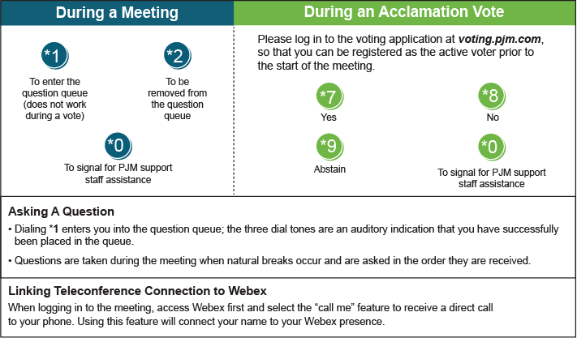

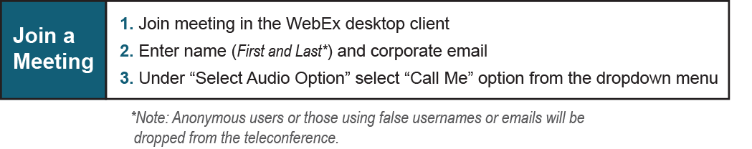

Provide feedback on the progress of this group: Facilitator Feedback Form
Visit learn.pjm.com, an easy-to-understand resource about the power industry and PJM’s role.

