April Planning Committee

**Teleconference / WebEx**

April 12, 2022

9:00 a.m. – 12:00 p.m. EPT

Administration (9:00 – 9:15)

1. Welcome, announcements and review of the Anti-trust, Code of Conduct, and Media Participation Guidelines.
2. Approve Planning Committee (PC) Agenda for this meeting.
3. Approve draft minutes from the March 8, 2022 PC meeting.
4. Dave Anders, PJM, will provide an update on the voting protocols for Board elections at the May Members Committee meeting.
5. Review the 2022 PC Work Plan.

Endorsements (9:15 – 9:45)

1. Manual 14F: Competitive Planning Process Update

Joseph Hay, PJM, will provide a review of Manual 14F regarding the biennial cover-to-cover review. The committee will be asked to vote on the manual changes at today’s meeting.

1. Manual 21A: Determination of Accredited UCAP Using Effective Load Carrying Capability Analysis

Joshua Bruno, PJM, will provide a review of Manual 21A revisions regarding an ELCC model run timing update and changes to reflect the continuation of the current method to provide unit specific backcasts only as requested. The committee will be asked to approve the Issue Charge and endorse the proposed Manual 21A revisions as part of the Quick Fix process outlined in Section 8.6.1 of Manual 34 at today’s meeting.

First Reads (9:45 – 10:30)

1. Interconnection Process Subcommittee

Jason Connell, PJM, will provide a first read of the draft charter of an Interconnection Process Subcommittee to continue the discussion of interconnection process improvements after the work of the IPRTF concludes. The committee will be asked to vote on the draft charter at next month’s meeting.

1. Application of Designated Entity Agreement

Augustine Caven, PJM, will provide a first read of the proposed solution to address the application of Designated Entity Agreement. The committee will be asked to approve the Issue Charge and endorse the proposed approach as part of the Quick Fix process outlined in Section 8.6.1 of Manual 34 at next month’s meeting.

1. RSCS Charter

Monica Burkett, PJM, will provide a first read of changes made to the Reliability Standards & Compliance Subcommittee Charter. The committee will be asked to vote on the draft charter at next month’s meeting.

Informational Updates (10:30 – 12:00)

1. Capacity Interconnection Rights for ELCC Resources Update

Brian Chmielewski, PJM, will provide an update from the work done during the PC special session on Capacity Interconnection Rights (CIR) for ELCC Resources.

[Issue Tracking: CIRs for ELCC Resources](https://www.pjm.com/committees-and-groups/issue-tracking/issue-tracking-details.aspx?Issue=83aadda8-b6c1-4630-9483-025b6b93fc28)

Materials for the special sessions can be found [here](https://www.pjm.com/committees-and-groups/committees/pc).

1. Generator Deliverability Timeline Update

Jonathan Kern, PJM, will provide a generator deliverability proposal development timeline update.

1. Interconnection Queue Update

Jason Shoemaker, PJM, will review status of the PJM Interconnection Queues.

1. ~~Manual 03: Transmission Operations Update~~

~~Dean Manno, PJM, will provide a periodic review update on Manual 3 revisions.~~

1. Reliability Compliance Update  
   Becky Davis, PJM, will provide an update on the activities, issues and items of interest at NERC, SERC, and RF.
2. Interconnection Process Reform
   1. Representatives from the PJM Interconnection Customer Coalition will review a proposed amendment to the Interconnection Process Reform solution endorsed by the PC.
   2. Alex Stern, PSEG, and Jim Davis, Dominion, will review an additional proposed amendment and address a transition to the new rules.
   3. Michael Yuffee, representing Hollow Road Solar, will provide some information related to the Interconnection Process Reform and PURPA.

Informational Posting

Model Build Activity Update

* MMWG
  + Dynamics
    - PJM is helping PowerTech to resolve the identified issues of 20 seconds flat run for MMWG 2021 series dynamic cases
    - PJM is helping PowerTech to build the minimum inertia dynamic case for EIPC FRWG’s Eastern Interconnection Frequency Response study
* RTEP
  + Loadflow
    - The 2027 Light Load, Summer and Winter cases and associated files are being reviewed by PJM’s Transmission Planning and System Planning Modeling and Support Department
  + Short Circuit
    - PJM is applying feedback received from the Transmission Owners to the Trial 3 2024 model
    - The Trial 3 2024 RTEP short circuit case and files along with Trial 1 2027 RTEP short circuit case will be delivered by end of March, 2022
* The upcoming Gen Model Window for MOD-032 data submittals for applicable Generator Owners will open on Sunday, May 1st, 2022 and end on Wednesday, June 15th, 2022

MOD-032 Update

* The Gen Model window will open May 1 and remain open through June 15. Generator Owners have the option of using data submitted in previous years to prepopulate the 2022 forms. For any questions or comments email [MOD-032@pjm.com](mailto:MOD-032@pjm.com)
* The 2022 yearly updates to the Gen Model Users Guide and MOD-032 Data Requirements Documents will be issued in early April.  All applicable contacts on the Gen Model Mailing List will be informed via a separate email when the updated documents are publically available.
* No major updates have been made to the Gen Model site since last year.
* Link to Gen Model and relevant documents: <https://www.pjm.com/markets-and-operations/etools/planning-center>

Manual 03 Updates

Updates to PJM Manual 03, Revision 61 – Transmission Operations are posted as informational only with meeting materials

PC Special Session – DEA Education

DEA Education Session is scheduled for April 12th, 2022 from 3:00 – 5:00 p.m. EPT. Materials for the special session can be found [here](https://www.pjm.com/committees-and-groups/committees/pc).

|  |  |  |  |  |
| --- | --- | --- | --- | --- |
| **Future Meeting Dates and Materials** | | | **Materials Due  to Secretary** | **Materials Published** |
| Date | Time | Meeting (Location) |
| Tuesday, May 10, 2022 | 9:00 a.m. – 12:00 p.m. | Planning Committee (TBD) | Thursday, April 28, 2022 | Tuesday, May 3, 2022 |
| Tuesday, June 7, 2022 | 9:00 a.m. – 12:00 p.m. | Planning Committee (TBD) | Thursday, May 26, 2022 | Tuesday, May 31, 2022 |
| Tuesday,  July 12, 2022 | 9:00 a.m. – 12:00 p.m. | Planning Committee (TBD) | Thursday, June 30, 2022 | Tuesday, July 5, 2022 |
| Tuesday, August 9, 2022 | 9:00 a.m. – 12:00 p.m. | Planning Committee (TBD) | Thursday, July 28, 2022 | Tuesday, August 2, 2022 |
| Tuesday, September 6, 2022 | 9:00 a.m. – 12:00 p.m. | Planning Committee (TBD) | Thursday, August 25, 2022 | Tuesday, August 30, 2022 |

Author: Marilyn Jayachandran

Antitrust:

You may not discuss any topics that violate, or that might appear to violate, the antitrust laws including but not limited to agreements between or among competitors regarding prices, bid and offer practices, availability of service, product design, terms of sale, division of markets, allocation of customers or any other activity that might unreasonably restrain competition. If any of these items are discussed the chair will re-direct the conversation. If the conversation still persists, parties will be asked to leave the meeting or the meeting will be adjourned.

Code of Conduct:

As a mandatory condition of attendance at today's meeting, attendees agree to adhere to the PJM Code of Conduct as detailed in PJM Manual M-34 section 4.5, including, but not limited to, participants' responsibilities and rules regarding the dissemination of meeting discussion and materials.

Public Meetings/Media Participation:

Unless otherwise noted, PJM stakeholder meetings are open to the public and to members of the media. Members of the media are asked to announce their attendance at all PJM stakeholder meetings at the beginning of the meeting or at the point they join a meeting already in progress. Members of the Media are reminded that speakers at PJM meetings cannot be quoted without explicit permission from the speaker. PJM Members are reminded that "detailed transcriptional meeting notes" and white board notes from "brainstorming sessions" shall not be disseminated. Stakeholders are also not allowed to create audio, video or online recordings of PJM meetings. PJM may create audio, video or online recordings of stakeholder meetings for internal and training purposes, and your participation at such meetings indicates your consent to the same.

Participant Identification in WebEx:

When logging into the WebEx desktop client, please enter your real first and last name as well as a valid email address. Be sure to select the “call me” option.

PJM support staff continuously monitors WebEx connections during stakeholder meetings. Anonymous users or those using false usernames or emails will be dropped from the teleconference.

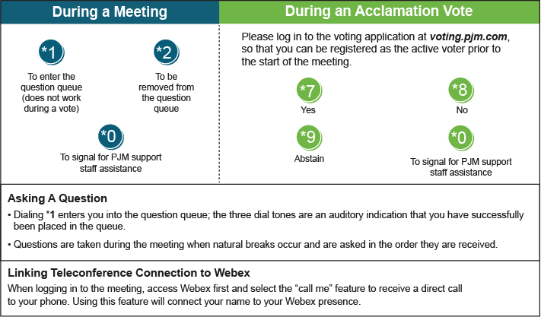

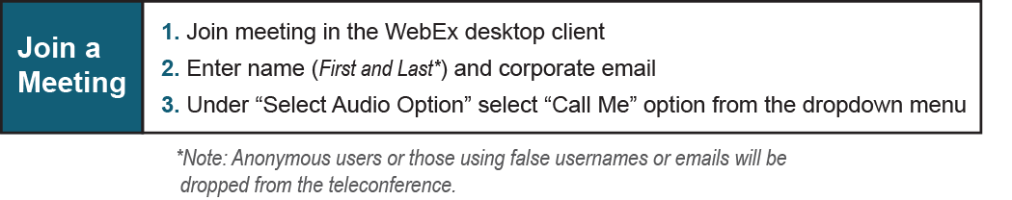

Provide feedback on the progress of this group: *Facilitator Feedback Form*   
Visit [*learn.pjm.com*](http://learn.pjm.com/), an easy-to-understand resource about the power industry and PJM’s role.