Demand Response Subcommittee
PJM Conference and Training Center
May 21, 2018
9:30 a.m. – 11:15 p.m. EPT

Administration (9:30-9:40)
- Welcome, Announcements and Anti-trust and Code of Conduct announcement
- Roll call: in-person only
- Review prior minutes – 4/18/2018 meeting
- Request for any additional agenda items
- Brief update/discussion of DR related activity in other stakeholder groups – MIC, OC, PC, or other
- Discussion of any issues regarding the current Load Management registration process for 2018/19 Delivery Year registrations (all registrations must be finalized by 5/31 or they will be terminated).

Seasonal DR Aggregation Registration Rules (9:40-10:15)
- Ms. Andrea Yeaton, PJM, will review Manual and Tariff language representing the consensus package.

DR CP Winter Peak Load Calculation (10:15-10:25)
- Mr. Jack O’Neill, PJM, will review updated Governing Document changes for the WPL changes supported by the DRS which also went through first read at last MIC. PJM legal team determined the RAA should be changed as well as the PJM Manual.

DR Hub Update (10:25 – 10:35)
- Ms. Andrea Yeaton, PJM, will review highlights of the next DR Hub release targeted for the end of May.

Results of Summer Drill (10:35-10:45)
- Mr. Pete Langbein, PJM, will review the Summer Drill that was conducted on Monday, May 14th.

Duplicate Resolution Process (10:45-10:55)
- Ms. Andrea Yeaton will review existing duplicate resolution process and actions required prior to start of Delivery Year to avoid termination of Load Management registration.

DR Hub change to require Webservice verification for CSP Load Management test events (10:55 – 11:15 )
- Mr. Jack O’Neill, PJM, will solicit feedback from CSPs about this proposed change that they gathered from their IT departments.

Future Agenda Items
Participants will have the opportunity to request the addition of any new item(s) to the agenda of a future meeting.

Future Meeting Dates
Friday | 6/22/2018 | 9:30 am – 4:00 pm | PJM Conference & Training Center/ Webex
Monday | 7/16/2018 | 9:30 am – 4:00 pm | PJM Conference & Training Center/ Webex
Thursday | 8/30/2018 | 9:30 am – 4:00 pm | PJM Conference & Training Center/ Webex
Tuesday | 9/25/2018 | 9:30 am – 4:00 pm | PJM Conference & Training Center/ Webex
Wednesday | 10/24/2018 | 9:30 am – 4:00 pm | PJM Conference & Training Center/ Webex
Friday | 11/16/2018 | 9:30 am – 4:00 pm | PJM Conference & Training Center/ Webex
Monday | 12/10/2018 | 9:30 am – 4:00 pm | PJM Conference & Training Center/ Webex

Author: Andrea Yeaton

Antitrust:
You may not discuss any topics that violate, or that might appear to violate, the antitrust laws including but not limited to agreements between or among competitors regarding prices, bid and offer practices, availability of service, product design, terms of sale, division of markets, allocation of customers or any other activity that might unreasonably restrain competition. If any of these items are discussed the chair will re-direct the conversation. If the conversation still persists, parties will be asked to leave the meeting or the meeting will be adjourned.

Code of Conduct:
As a mandatory condition of attendance at today's meeting, attendees agree to adhere to the PJM Code of Conduct as detailed in PJM Manual M-34 section 4.5, including, but not limited to, participants' responsibilities and rules regarding the dissemination of meeting discussion and materials.

Public Meetings/Media Participation:
Unless otherwise noted, PJM stakeholder meetings are open to the public and to members of the media. Members of the media are asked to announce their attendance at all PJM stakeholder meetings at the beginning of the meeting or at the point they join a meeting already in progress. Members of the Media are reminded that speakers at PJM meetings cannot be quoted without explicit permission from the speaker. PJM Members are reminded that "detailed transcriptional meeting notes" and white board notes from "brainstorming sessions" shall not be disseminated. Stakeholders are also not allowed to create audio, video or online recordings of PJM meetings.

Participant Identification in WebEx:
When logging into the WebEx desktop client, please enter your real first and last name as well as a valid email address. Be sure to select the “call me” option.
PJM support staff continuously monitors WebEx connections during stakeholder meetings. Anonymous users or those using false usernames or emails will be dropped from the teleconference.



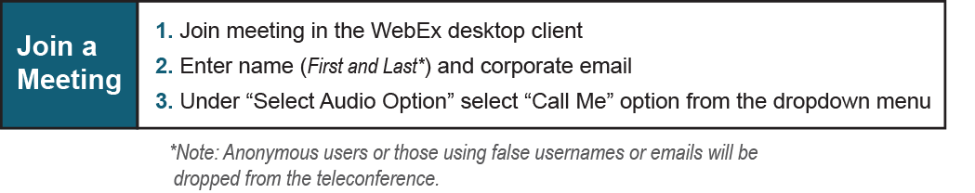

Provide feedback on the progress of this group: Facilitator Feedback Form
Visit learn.pjm.com an easy-to-understand resource about the power industry and PJM’s role.

