Market Settlements Subcommittee
Conference Call
December 14, 2023 (Canceled)

Informational Updates
- December 2023 and January 2024 Holiday Submission Deadline Extensions Reminder
Please review guidelines for submissions for December 2023 and January 2024 holiday dates.
Two key considerations:
- There are accelerated, earlier than normal, deadlines that PJM is expecting to be met on Thursday December 21, 2023.
- PJM expects all submitting members to have appropriate staffing in place on Tuesday December 26, 2023 to meet PowerMeter submission deadline data for December 21, 2023 through December 25, 2023 by 4PM EPT on December 26.

2023/2024 Holiday Submission Deadlines
2. Upcoming MSRS report changes
Please review details regarding upcoming MSRS Report column name changes for the Operating Reserve Generator Deviations – 5 Minute report. Additionally, report documentation will be updated for the Balancing Operating Reserve Generator Credit Details report.
MSRS Report Updates
- Billing Line Item Transfer (BLIT) Tool Enhancements
Enhancements discussed at the October 16, 2023 MSS meeting were released to BLIT Production on December 7, 2023.
- Settlement C Updates
One adjustment was processed in the November 2023 billing cycle impacting the Dayton zone.
Settlement C Adjustment Tracking

Future Agenda Items
Participants will have the opportunity to request the addition of any new item(s) to the agenda of a future meeting.

Future Meeting Dates
January 16, 2024 | 1:00 p.m. – 2:30 p.m. | Conference Call
February 13, 2024 | 1:00 p.m. – 2:30 p.m. | Conference Call
March 12, 2024 | 1:00 p.m. – 2:30 p.m. | Conference Call
April 16, 2024 | 1:00 p.m. – 2:30 p.m. | Conference Call

Author: Sean Flamm

Antitrust:
You may not discuss any topics that violate, or that might appear to violate, the antitrust laws including but not limited to agreements between or among competitors regarding prices, bid and offer practices, availability of service, product design, terms of sale, division of markets, allocation of customers or any other activity that might unreasonably restrain competition. If any of these items are discussed the chair will re-direct the conversation. If the conversation still persists, parties will be asked to leave the meeting or the meeting will be adjourned.

Code of Conduct:
As a mandatory condition of attendance at today's meeting, attendees agree to adhere to the PJM Code of Conduct as detailed in PJM Manual M-34 section 4.5, including, but not limited to, participants' responsibilities and rules regarding the dissemination of meeting discussion and materials. Expectations for participating in PJM activities are further detailed in the PJM Code of Conduct.

Public Meetings/Media Participation:
Unless otherwise noted, PJM stakeholder meetings are open to the public and to members of the media. Members of the media are asked to announce their attendance at all PJM stakeholder meetings at the beginning of the meeting or at the point they join a meeting already in progress. Members of the Media are reminded that speakers at PJM meetings cannot be quoted without explicit permission from the speaker. PJM Members are reminded that "detailed transcriptional meeting notes" and white board notes from "brainstorming sessions" shall not be disseminated. Stakeholders are also not allowed to create audio, video or online recordings of PJM meetings. PJM may create audio, video or online recordings of stakeholder meetings for internal and training purposes, and your participation at such meetings indicates your consent to the same.
Participant Identification in WebEx:
When logging into the WebEx desktop client, please enter your real first and last name as well as a valid email address. Be sure to select the “call me” option.
PJM support staff continuously monitors WebEx connections during stakeholder meetings. Anonymous users or those using false usernames or emails will be dropped from the teleconference.



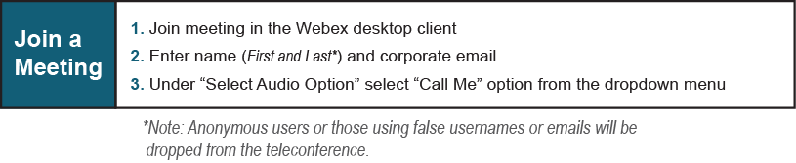
Provide feedback on the progress of this group: Facilitator Feedback Form
Visit learn.pjm.com, an easy-to-understand resource about the power industry and PJM’s role.

