Energy Price Formation Sr. Task Force
PJM Conference and Training Center
June 8, 2018
8:30 a.m. – 2:00 p.m. EPT

Administration (8:30-8:40)
- Mr. Dave Anders and Mr. Vijay Shah will provide announcements, review the Anti-trust, Code of Conduct and PJM meeting guidelines policies and perform in-room roll-call
- The Senior Task Force will be asked to approve draft minutes from the May 23, 2018 Energy Price Formation Senior Task Force (EPFSTF) meeting.

Operating Reserve Demand Curve (ORDC) (8:40-12:00)
- ORDC Discussion
- Mr. Troy Cawley, PJM, will provide a presentation on current methodology behind Minimum Reserve Requirement (MRR) determination and actions taken during emergency procedures
- Dr. Patricio A. Rocha Garrido, PJM, will provide a presentation expanding on the framework that was presented at May 23, 2018 EPFSTF meeting with more examples and continue discussion regarding any adjustments to the uncertainties that are used.
- Ms. Lisa Morelli, PJM, will provide a presentation on the consideration of using ORDC for Day Ahead Scheduling Reserve Market
- Dr. Catherine Tyler, IMM, will provide a presentation on analysis of PJM ORDC and historical Reserves
- Mr. Dave Anders will lead a discussion capturing design components and options to the EPFSTF matrix focusing on ORDC.
Lunch (12:00-12:30)

Reserve Zone Modeling (12:30-1:00)
- Reserve Zone Modeling
- Ms. Lisa Morelli, PJM, will provide a presentation on Locational Reserve Zone Modeling

Synchronized Reserves (1:00-2:00)
- Synchronized Reserves
- Dr. Catherine Tyler, IMM, will provide a presentation reviewing IMM’s proposal for Synchronized Reserves
- Mr. Dave Anders will lead a discussion capturing design components and options to the EPFSTF matrix focusing on the reserve market.
Meeting adjourned 2:00

Future Agenda Items

Future Meeting Dates
June 25, 2018 | 10:00 a.m. | PJM Conference & Training Center/ WebEx
July 17, 2018 | 9:30 a.m. | PJM Conference & Training Center/ WebEx
August 6, 2018 | 10:00 a.m. | PJM Conference & Training Center/ WebEx
August 22, 2018 | 10:00 a.m. | PJM Conference & Training Center/ WebEx
September 10, 2018 | 10:00 a.m. | PJM Conference & Training Center/ WebEx
October 12, 2018 | 9:00 a.m. | PJM Conference & Training Center/ WebEx
November 1, 2018 | 9:00 a.m. | PJM Conference & Training Center/ WebEx
November 28, 2018 | 9:00 a.m. | PJM Conference & Training Center/ WebEx
December 14, 2018 | 9:00 a.m. | PJM Conference & Training Center/ WebEx

Author: Vijay Shah

Antitrust:
You may not discuss any topics that violate, or that might appear to violate, the antitrust laws including but not limited to agreements between or among competitors regarding prices, bid and offer practices, availability of service, product design, terms of sale, division of markets, allocation of customers or any other activity that might unreasonably restrain competition. If any of these items are discussed the chair will re-direct the conversation. If the conversation still persists, parties will be asked to leave the meeting or the meeting will be adjourned.

Code of Conduct:
As a mandatory condition of attendance at today's meeting, attendees agree to adhere to the PJM Code of Conduct as detailed in PJM Manual M-34 section 4.5, including, but not limited to, participants' responsibilities and rules regarding the dissemination of meeting discussion and materials.

Public Meetings/Media Participation:
Unless otherwise noted, PJM stakeholder meetings are open to the public and to members of the media. Members of the media are asked to announce their attendance at all PJM stakeholder meetings at the beginning of the meeting or at the point they join a meeting already in progress. Members of the Media are reminded that speakers at PJM meetings cannot be quoted without explicit permission from the speaker. PJM Members are reminded that "detailed transcriptional meeting notes" and white board notes from "brainstorming sessions" shall not be disseminated. Stakeholders are also not allowed to create audio, video or online recordings of PJM meetings. PJM may create audio, video or online recordings of stakeholder meetings for internal and training purposes, and your participation at such meetings indicates your consent to the same.
Participant Identification in WebEx:
When logging into the WebEx desktop client, please enter your real first and last name as well as a valid email address. Be sure to select the “call me” option.
PJM support staff continuously monitors WebEx connections during stakeholder meetings. Anonymous users or those using false usernames or emails will be dropped from the teleconference.

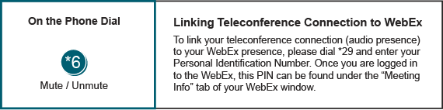

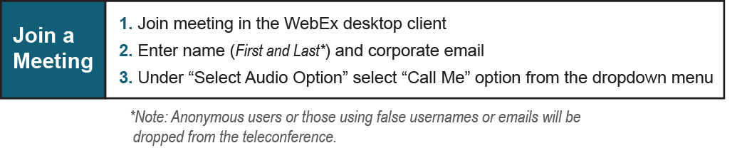

Provide feedback on the progress of this group: Facilitator Feedback Form
Visit learn.pjm.com, an easy-to-understand resource about the power industry and PJM’s role.

