Fuel Security Senior Task Force
PJM Conference and Training Center
April 05, 2019
9:00 a.m. – 4:00 p.m. EPT

Administration (9:00-9:10)
Ms. Melissa Pilong will provide welcome, announcements and review of the Antitrust, Code of Conduct, and Public Meetings/Media Participation Guidelines.

Task Force Initiation (9:10-10:40)
Problem Statement/ Issue Charge Overview (09:10-9:30)
Mr. Timothy Horger will lead a review of the Fuel Security Senior Task Force Problem Statement and Issue Charge approved by the Markets & Reliability Committee at its March 21, 2019 meeting.
Draft Charter (09:30-10:00)
Ms. Rebecca Carroll will review the draft charter for the Fuel Security Senior Task Force (FSSTF).
Work Plan (10:00-10:30)
Ms. Rebecca Carroll will lead a discussion of the work plan and meeting schedule for FSSTF.
Break (10:30-10:45)

Education (10:45-4:00)
NERC Special Reliability Assessment (Generation Retirement Scenario) and related NERC initiatives (10:45-12:00)
Mr. Thomas Coleman, NERC Director of Risk Issues Management, and Mr. John Moura, NERC Director of Reliability Assessment and Technical Committees, will discuss the NERC Generation Retirement Scenario - Special Reliability Assessment - and other Fuel/Energy Security initiatives.
Lunch (12:00-1:00)
- Resiliency and Reliability (1:00-1:30)
Mr. Timothy Horger will provide an overview on the differences between Fuel Security, Capacity Performance, and Reserve Price Formation. Mr. David Souder will lead a discussion on High-Impact Low-Frequency Event Probability in the context of Resilience.
Phase 1 Analysis (1:30-4:00)
Mr. Asanga Perera and Mr. David Souder will provide a summary on the scope of Phase 1 analysis and engage stakeholders in a discussion regarding additional requested scenarios.
Break (2:30-2:45)

Future Agenda Items

Future Meeting Dates
April 26, 2019 | 9:00 a.m.- 4:00 p.m. | PJM Conference & Training Center/ WebEx
May 17, 2019 | 9:00 a.m.- 4:00 p.m. | PJM Conference & Training Center/ WebEx
June 05, 2019 | 9:00 a.m.- 4:00 p.m. | PJM Conference & Training Center/ WebEx
June 26, 2019 | 9:00 a.m.- 4:00 p.m. | PJM Conference & Training Center/ WebEx
July 16, 2019 | 9:00 a.m.- 4:00 p.m. | PJM Conference & Training Center/ WebEx
August 12, 2019 | 9:00 a.m.- 4:00 p.m. | PJM Conference & Training Center/ WebEx
September 6, 2019 | 9:00 a.m.- 4:00 p.m. | PJM Conference & Training Center/ WebEx
Author: Melissa Pilong

Antitrust:
You may not discuss any topics that violate, or that might appear to violate, the antitrust laws including but not limited to agreements between or among competitors regarding prices, bid and offer practices, availability of service, product design, terms of sale, division of markets, allocation of customers or any other activity that might unreasonably restrain competition. If any of these items are discussed the chair will re-direct the conversation. If the conversation still persists, parties will be asked to leave the meeting or the meeting will be adjourned.

Code of Conduct:
As a mandatory condition of attendance at today's meeting, attendees agree to adhere to the PJM Code of Conduct as detailed in PJM Manual M-34 section 4.5, including, but not limited to, participants' responsibilities and rules regarding the dissemination of meeting discussion and materials.

Public Meetings/Media Participation:
Unless otherwise noted, PJM stakeholder meetings are open to the public and to members of the media. Members of the media are asked to announce their attendance at all PJM stakeholder meetings at the beginning of the meeting or at the point they join a meeting already in progress. Members of the Media are reminded that speakers at PJM meetings cannot be quoted without explicit permission from the speaker. PJM Members are reminded that "detailed transcriptional meeting notes" and white board notes from "brainstorming sessions" shall not be disseminated. Stakeholders are also not allowed to create audio, video or online recordings of PJM meetings. PJM may create audio, video or online recordings of stakeholder meetings for internal and training purposes, and your participation at such meetings indicates your consent to the same.
Participant Identification in WebEx:
When logging into the WebEx desktop client, please enter your real first and last name as well as a valid email address. Be sure to select the “call me” option.
PJM support staff continuously monitors WebEx connections during stakeholder meetings. Anonymous users or those using false usernames or emails will be dropped from the teleconference.



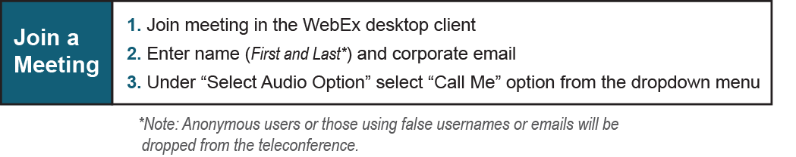

Provide feedback on the progress of this group: Facilitator Feedback Form
Visit learn.pjm.com, an easy-to-understand resource about the power industry and PJM’s role.

